ｽﾍﾟｸﾄﾙﾗﾍﾞﾙ: ｽﾍﾟｸﾄﾙ 1

ﾗｲﾌﾞﾀｲﾑ 120.0 s

収集ｼﾞｵﾒﾄﾘ[度] :

試料傾斜角 = 0.0

方位角 = 0.0

ｴﾚﾍﾞｰｼｮﾝ = 30.0

加速電圧 = 10.00 kV

ｽﾍﾟｸﾄﾙ全ｶｳﾝﾄ数 = 207453

|  |  |  |  |
| --- | --- | --- | --- |
| ｻﾝﾌﾟﾙﾃﾞｰﾀ : | ｴﾈﾙｷﾞｰ[eV] | 分解能[eV] | ｶｳﾝﾄ数 |
| ｽﾄﾛｰﾌﾞ : | 3.8 | 51.92 | 1195149 |
|  |  |  |  |

定量最適化がおこなわれていません

ｽﾍﾟｸﾄﾙ処理 :

省略されたﾋﾟｰｸはありません

処理ｵﾌﾟｼｮﾝ : 酸素 ｽﾄｲｷｵﾒﾄﾘ (ﾉｰﾏﾗｲｽﾞ)

繰り返し回数 = 2

ｽﾀﾝﾀﾞｰﾄﾞ :

Na Albite 1999/06/01

Mg MgO 1999/06/01

Al Al2O3 1999/06/01

Si SiO2 1999/06/01

P GaP 1999/06/01

S FeS2 1999/06/01

K MAD-10 Feldspar 1999/06/01

Ca Wollastonite 1999/06/01

Cr Cr 1999/06/01

Mn Mn 1999/06/01

Fe Fe 1999/06/01

Ni Ni 1999/06/01

|  |  |  |  |  |  |
| --- | --- | --- | --- | --- | --- |
| 元素 | 質量濃度 | 原子数 | 化合物 | 化学式 |  |
|  | [%] | 濃度[%] | 濃度[%] |  |  |
| Na K | -0.86 | -1.15 | -1.16 | Na2O |  |
| Mg K | 92.76 | 117.23 | 153.80 | MgO |  |
| Al K | 1.38 | 1.57 | 2.60 | Al2O3 |  |
| Si K | 71.98 | 78.74 | 153.99 | SiO2 |  |
| P K | -68.27 | -67.72 | -156.42 | P2O5 |  |
| S K | -52.31 | -50.12 | -130.61 | SO3 |  |
| K K | -1.72 | -1.35 | -2.07 | K2O |  |
| Ca K | -0.42 | -0.32 | -0.59 | CaO |  |
| Cr K | -2.62 | -1.55 | -3.82 | Cr2O3 |  |
| Mn K | -3.98 | -2.23 | -5.14 | MnO |  |
| Fe K | 48.75 | 26.82 | 62.71 | FeO |  |
| Ni K | 20.98 | 10.98 | 26.70 | NiO |  |
| O | -5.68 | -10.90 |  |  |  |
| ﾄｰﾀﾙ | 100.00 |  |  |  |  |

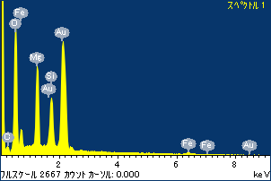

ﾌﾟﾛｼﾞｪｸﾄ : ﾌﾟﾛｼﾞｪｸﾄ 120110516

ｵｰﾅｰ : Administrator

領域 分析領域 1

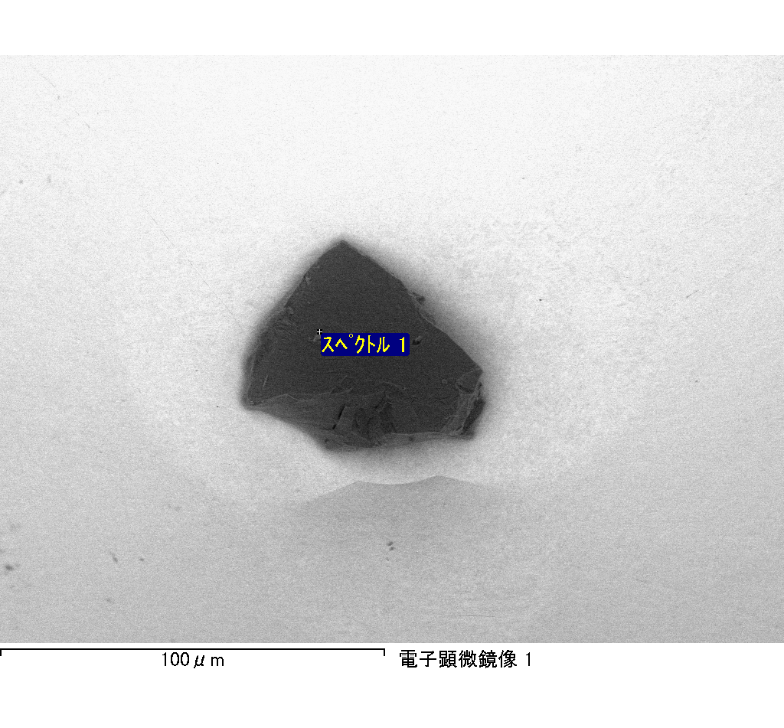

ｽﾍﾟｸﾄﾙﾗﾍﾞﾙ: ｽﾍﾟｸﾄﾙ 2

ﾗｲﾌﾞﾀｲﾑ 104.3 s

収集ｼﾞｵﾒﾄﾘ[度] :

試料傾斜角 = 0.0

方位角 = 0.0

ｴﾚﾍﾞｰｼｮﾝ = 30.0

加速電圧 = 10.00 kV

ｽﾍﾟｸﾄﾙ全ｶｳﾝﾄ数 = 166674

|  |  |  |  |
| --- | --- | --- | --- |
| ｻﾝﾌﾟﾙﾃﾞｰﾀ : | ｴﾈﾙｷﾞｰ[eV] | 分解能[eV] | ｶｳﾝﾄ数 |
| ｽﾄﾛｰﾌﾞ : | 3.8 | 51.79 | 1039957 |
|  |  |  |  |

定量最適化がおこなわれていません

ｽﾍﾟｸﾄﾙ処理 :

省略されたﾋﾟｰｸはありません

処理ｵﾌﾟｼｮﾝ : 酸素 ｽﾄｲｷｵﾒﾄﾘ (ﾉｰﾏﾗｲｽﾞ)

繰り返し回数 = 2

ｽﾀﾝﾀﾞｰﾄﾞ :

Na Albite 1999/06/01

Mg MgO 1999/06/01

Al Al2O3 1999/06/01

Si SiO2 1999/06/01

P GaP 1999/06/01

S FeS2 1999/06/01

K MAD-10 Feldspar 1999/06/01

Ca Wollastonite 1999/06/01

Cr Cr 1999/06/01

Mn Mn 1999/06/01

Fe Fe 1999/06/01

Ni Ni 1999/06/01

|  |  |  |  |  |  |
| --- | --- | --- | --- | --- | --- |
| 元素 | 質量濃度 | 原子数 | 化合物 | 化学式 |  |
|  | [%] | 濃度[%] | 濃度[%] |  |  |
| Na K | -1.01 | -0.58 | -1.36 | Na2O |  |
| Mg K | -133.27 | -73.10 | -220.96 | MgO |  |
| Al K | -1.42 | -0.70 | -2.68 | Al2O3 |  |
| Si K | -108.67 | -51.60 | -232.48 | SiO2 |  |
| P K | 157.01 | 67.60 | 359.76 | P2O5 |  |
| S K | 129.92 | 54.04 | 324.40 | SO3 |  |
| K K | 2.46 | 0.84 | 2.96 | K2O |  |
| Ca K | -5.37 | -1.79 | -7.52 | CaO |  |
| Cr K | -14.27 | -3.66 | -20.85 | Cr2O3 |  |
| Mn K | -0.45 | -0.11 | -0.58 | MnO |  |
| Fe K | -81.34 | -19.42 | -104.65 | FeO |  |
| Ni K | 3.10 | 0.70 | 3.94 | NiO |  |
| O | 153.30 | 127.78 |  |  |  |
| ﾄｰﾀﾙ | 100.00 |  |  |  |  |

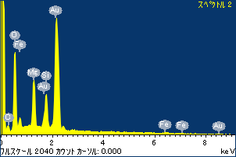

ﾌﾟﾛｼﾞｪｸﾄ : ﾌﾟﾛｼﾞｪｸﾄ 120110516

ｵｰﾅｰ : Administrator

領域 分析領域 1

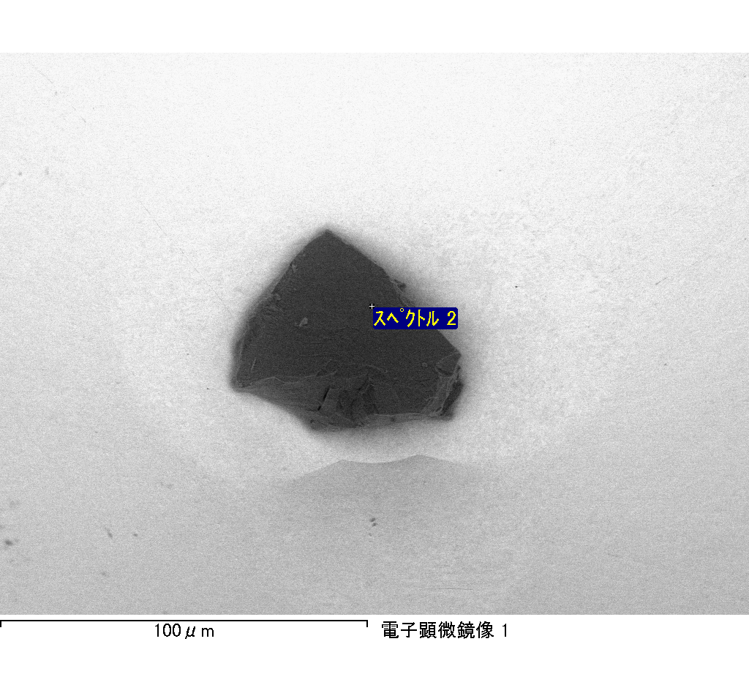

ｽﾍﾟｸﾄﾙﾗﾍﾞﾙ: ｽﾍﾟｸﾄﾙ 1

ﾗｲﾌﾞﾀｲﾑ 120.0 s

収集ｼﾞｵﾒﾄﾘ[度] :

試料傾斜角 = 0.0

方位角 = 0.0

ｴﾚﾍﾞｰｼｮﾝ = 30.0

加速電圧 = 10.00 kV

ｽﾍﾟｸﾄﾙ全ｶｳﾝﾄ数 = 201649

|  |  |  |  |
| --- | --- | --- | --- |
| ｻﾝﾌﾟﾙﾃﾞｰﾀ : | ｴﾈﾙｷﾞｰ[eV] | 分解能[eV] | ｶｳﾝﾄ数 |
| ｽﾄﾛｰﾌﾞ : | 3.8 | 51.84 | 1195029 |
|  |  |  |  |

定量最適化がおこなわれていません

ｽﾍﾟｸﾄﾙ処理 :

省略されたﾋﾟｰｸはありません

処理ｵﾌﾟｼｮﾝ : 酸素 ｽﾄｲｷｵﾒﾄﾘ (ﾉｰﾏﾗｲｽﾞ)

繰り返し回数 = 2

ｽﾀﾝﾀﾞｰﾄﾞ :

Na Albite 1999/06/01

Mg MgO 1999/06/01

Al Al2O3 1999/06/01

Si SiO2 1999/06/01

P GaP 1999/06/01

S FeS2 1999/06/01

K MAD-10 Feldspar 1999/06/01

Ca Wollastonite 1999/06/01

Cr Cr 1999/06/01

Mn Mn 1999/06/01

Fe Fe 1999/06/01

Ni Ni 1999/06/01

|  |  |  |  |  |  |
| --- | --- | --- | --- | --- | --- |
| 元素 | 質量濃度 | 原子数 | 化合物 | 化学式 |  |
|  | [%] | 濃度[%] | 濃度[%] |  |  |
| Na K | 8.00 | 8.72 | 10.79 | Na2O |  |
| Mg K | 34.18 | 35.22 | 56.67 | MgO |  |
| Al K | 10.75 | 9.98 | 20.31 | Al2O3 |  |
| Si K | 62.08 | 55.37 | 132.80 | SiO2 |  |
| P K | -39.35 | -31.82 | -90.16 | P2O5 |  |
| S K | -29.67 | -23.18 | -74.09 | SO3 |  |
| K K | 1.26 | 0.81 | 1.52 | K2O |  |
| Ca K | 0.18 | 0.12 | 0.26 | CaO |  |
| Cr K | -4.37 | -2.11 | -6.39 | Cr2O3 |  |
| Mn K | 1.88 | 0.86 | 2.42 | MnO |  |
| Fe K | 25.82 | 11.58 | 33.22 | FeO |  |
| Ni K | 9.93 | 4.24 | 12.64 | NiO |  |
| O | 19.30 | 30.22 |  |  |  |
| ﾄｰﾀﾙ | 100.00 |  |  |  |  |

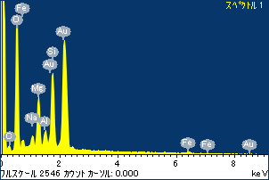

ﾌﾟﾛｼﾞｪｸﾄ : ﾌﾟﾛｼﾞｪｸﾄ 120110516

ｵｰﾅｰ : Administrator

領域 分析領域 3

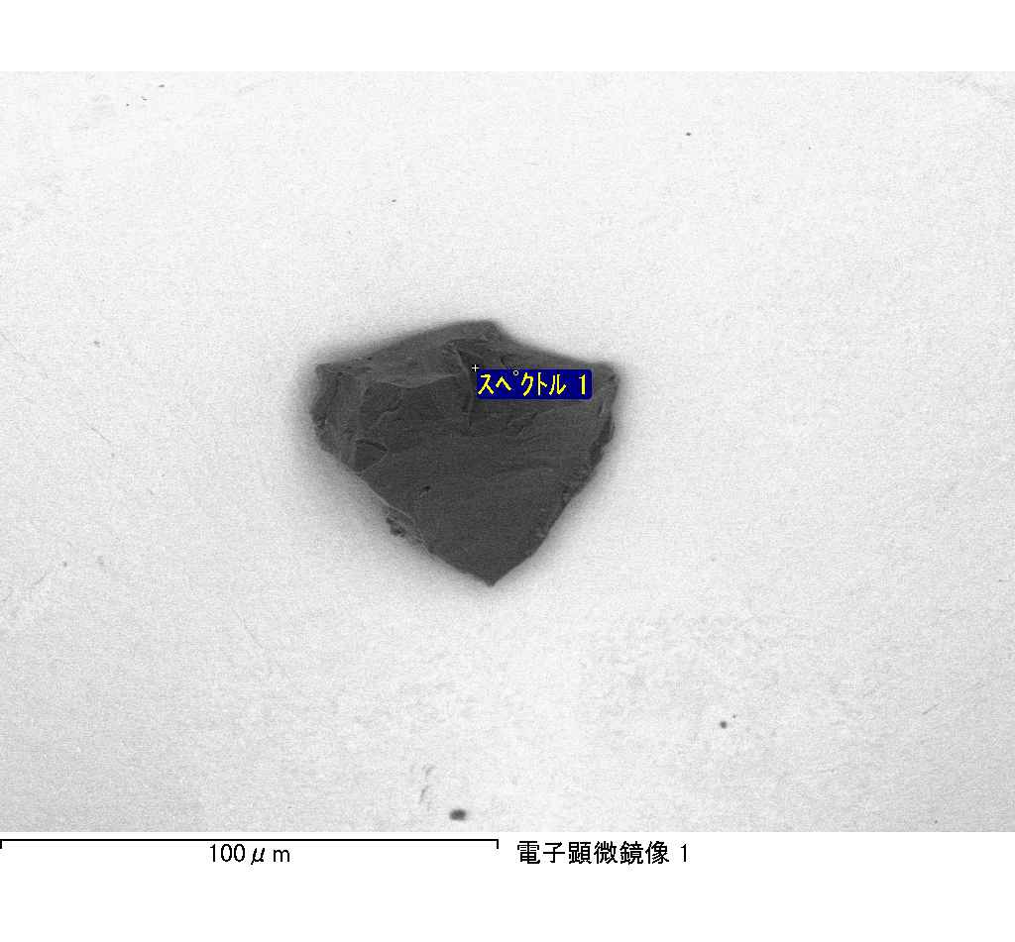

ｽﾍﾟｸﾄﾙﾗﾍﾞﾙ: ｽﾍﾟｸﾄﾙ 4

ﾗｲﾌﾞﾀｲﾑ 120.0 s

収集ｼﾞｵﾒﾄﾘ[度] :

試料傾斜角 = 0.0

方位角 = 0.0

ｴﾚﾍﾞｰｼｮﾝ = 30.0

加速電圧 = 10.00 kV

ｽﾍﾟｸﾄﾙ全ｶｳﾝﾄ数 = 195427

|  |  |  |  |
| --- | --- | --- | --- |
| ｻﾝﾌﾟﾙﾃﾞｰﾀ : | ｴﾈﾙｷﾞｰ[eV] | 分解能[eV] | ｶｳﾝﾄ数 |
| ｽﾄﾛｰﾌﾞ : | 3.8 | 51.87 | 1194771 |
|  |  |  |  |

定量最適化がおこなわれていません

ｽﾍﾟｸﾄﾙ処理 :

定量計算に使用されていないﾋﾟｰｸ : 2.801 keV

処理ｵﾌﾟｼｮﾝ : 酸素 ｽﾄｲｷｵﾒﾄﾘ (ﾉｰﾏﾗｲｽﾞ)

繰り返し回数 = 2

ｽﾀﾝﾀﾞｰﾄﾞ :

Na Albite 1999/06/01

Mg MgO 1999/06/01

Al Al2O3 1999/06/01

Si SiO2 1999/06/01

P GaP 1999/06/01

S FeS2 1999/06/01

K MAD-10 Feldspar 1999/06/01

Ca Wollastonite 1999/06/01

Cr Cr 1999/06/01

Mn Mn 1999/06/01

Fe Fe 1999/06/01

Ni Ni 1999/06/01

|  |  |  |  |  |  |
| --- | --- | --- | --- | --- | --- |
| 元素 | 質量濃度 | 原子数 | 化合物 | 化学式 |  |
|  | [%] | 濃度[%] | 濃度[%] |  |  |
| Na K | -0.68 | -1.04 | -0.91 | Na2O |  |
| Mg K | 109.30 | 158.03 | 181.22 | MgO |  |
| Al K | 1.35 | 1.76 | 2.56 | Al2O3 |  |
| Si K | 91.40 | 114.39 | 195.52 | SiO2 |  |
| P K | -90.72 | -102.96 | -207.87 | P2O5 |  |
| S K | -68.03 | -74.59 | -169.87 | SO3 |  |
| K K | -0.27 | -0.24 | -0.32 | K2O |  |
| Ca K | 3.57 | 3.13 | 4.99 | CaO |  |
| Cr K | -7.18 | -4.86 | -10.50 | Cr2O3 |  |
| Mn K | -0.18 | -0.11 | -0.23 | MnO |  |
| Fe K | 80.35 | 50.58 | 103.37 | FeO |  |
| Ni K | 1.60 | 0.96 | 2.04 | NiO |  |
| O | -20.51 | -45.06 |  |  |  |
| ﾄｰﾀﾙ | 100.00 |  |  |  |  |

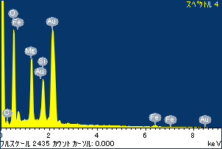

ﾌﾟﾛｼﾞｪｸﾄ : ﾌﾟﾛｼﾞｪｸﾄ 120110516

ｵｰﾅｰ : Administrator

領域 分析領域 3

