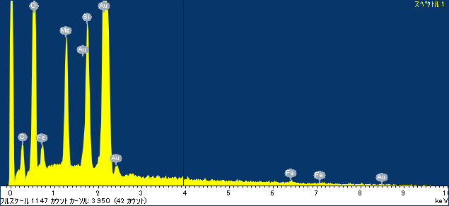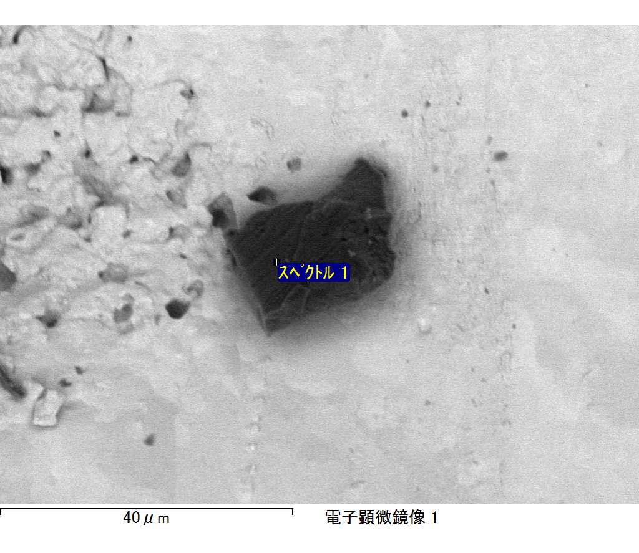

ｺﾒﾝﾄ :

2017/12/27 12:09:24

ﾌﾟﾛｼﾞｪｸﾄ 1

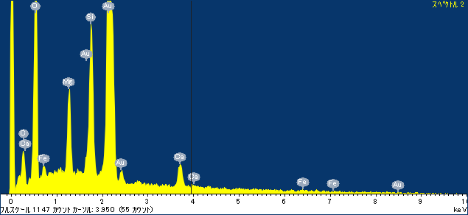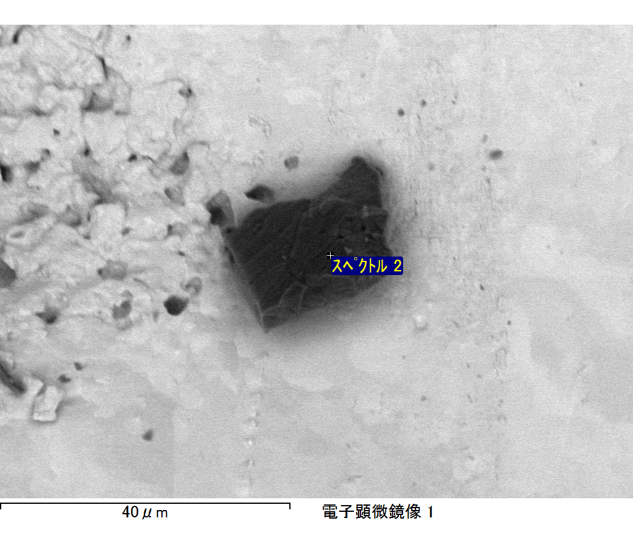

ｺﾒﾝﾄ :

2017/12/27 12:09:28

ﾌﾟﾛｼﾞｪｸﾄ 1

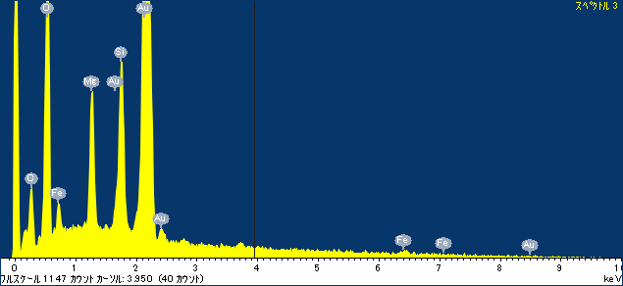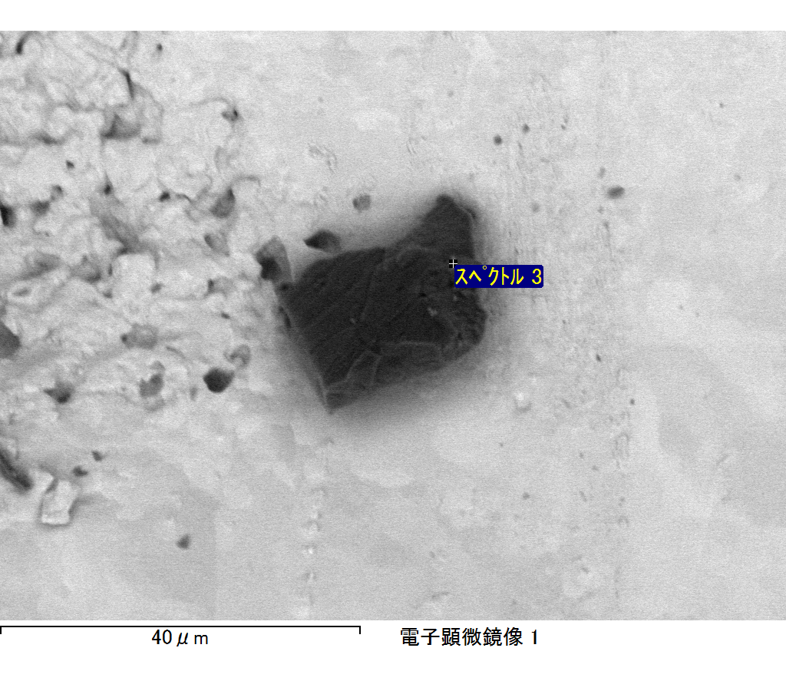

ｺﾒﾝﾄ :

2017/12/27 12:09:31

ﾌﾟﾛｼﾞｪｸﾄ 1

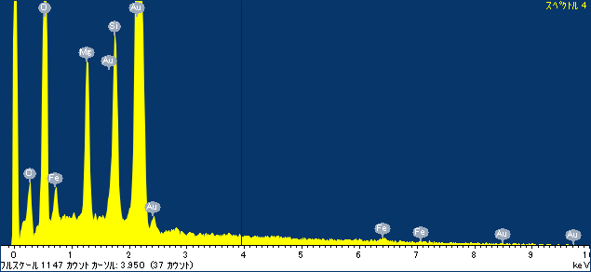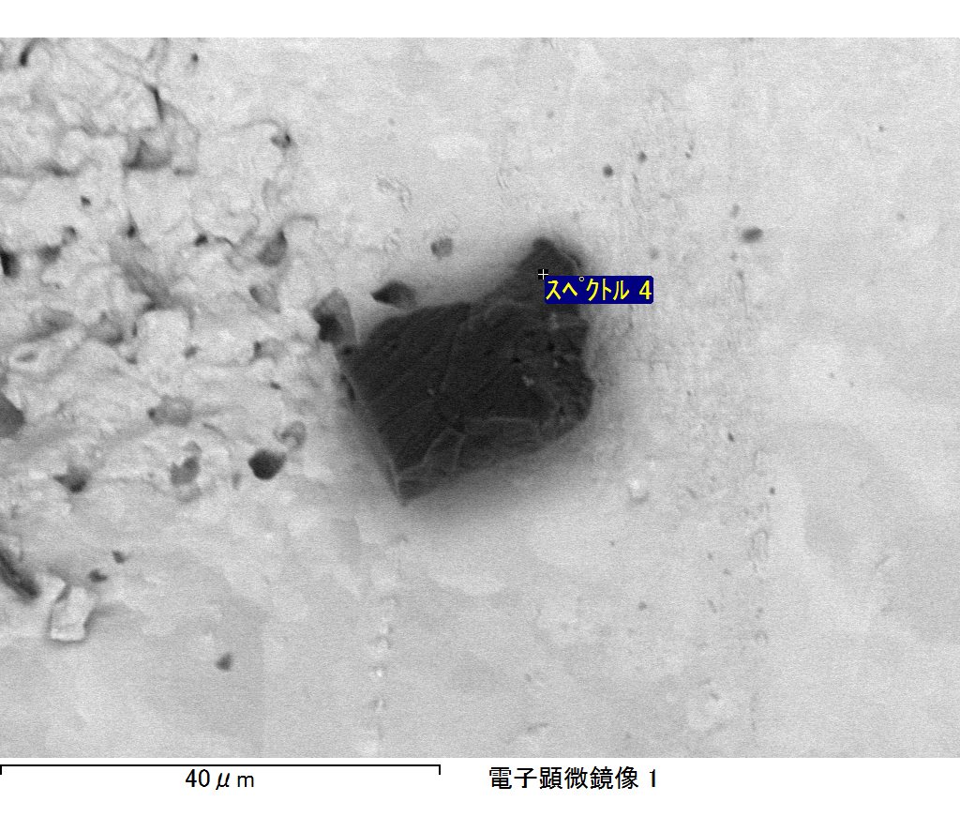

ｺﾒﾝﾄ :

2017/12/27 12:09:35

ﾌﾟﾛｼﾞｪｸﾄ 1

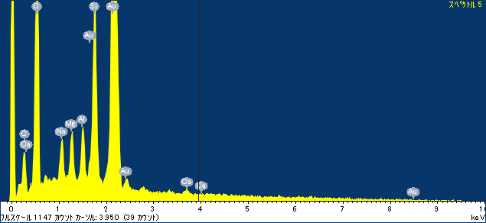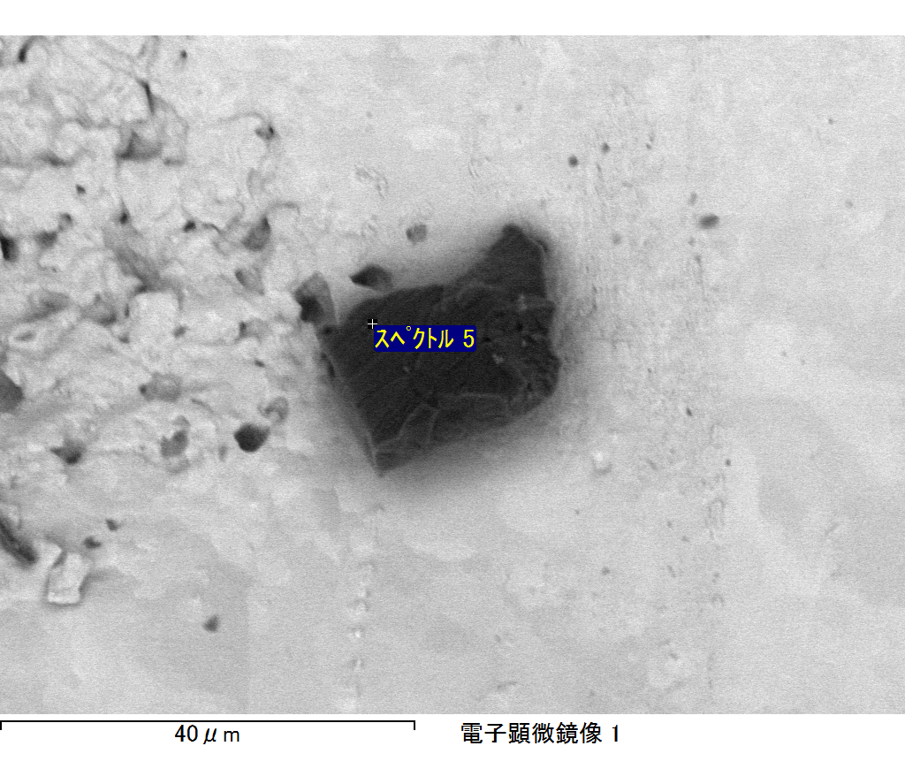

ｺﾒﾝﾄ :

2017/12/27 12:09:41

ﾌﾟﾛｼﾞｪｸﾄ 1