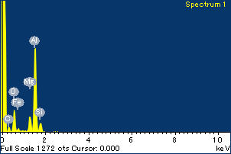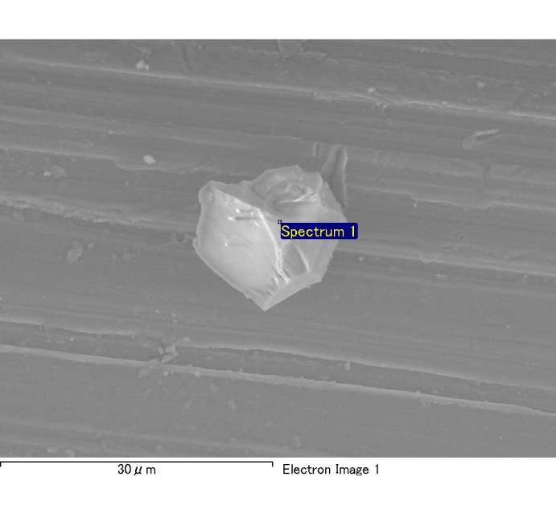

Spectrum Label: Spectrum 1

Livetime 120.0 s

Acquisition geometry ( degrees ):

Tilt = 0.0

Azimuth = 0.0

Elevation = 30.0

Accelerating voltage = 10.00 kV

Total spectrum counts = 120875

|  |  |  |  |
| --- | --- | --- | --- |
| Sample data : | Energy (eV) | Resn. (eV) | Area |
| Strobe : | 3.8 | 54.01 | 1209311 |
|  |  |  |  |
| Optimization data : Cobalt K series |  |  |  |
|  | Energy (eV) | Resn. (eV) | Area |
| Strobe : | .1 | 53.96 | 498142 |
| Optimization element : | 6926.7 | 142.17 | 16696 |

Spectrum processing :

No peaks omitted

Processing option : Oxygen by stoichiometry

Number of iterations = 2

Standard :

Na Albite 1-Jun-1999 12:00 AM

Mg MgO 1-Jun-1999 12:00 AM

Al Al2O3 1-Jun-1999 12:00 AM

Si SiO2 1-Jun-1999 12:00 AM

P GaP 1-Jun-1999 12:00 AM

S FeS2 1-Jun-1999 12:00 AM

K MAD-10 Feldspar 1-Jun-1999 12:00 AM

Ca Wollastonite 1-Jun-1999 12:00 AM

Cr Cr 1-Jun-1999 12:00 AM

Mn Mn 1-Jun-1999 12:00 AM

Fe Fe 1-Jun-1999 12:00 AM

Ni Ni 1-Jun-1999 12:00 AM

|  |  |  |  |  |  |
| --- | --- | --- | --- | --- | --- |
| Element | Weight% | Atomic% | Compd% | Formula |  |
|  |  |  |  |  |  |
| Na K | 0.00 | 0.03 | 0.00 | Na2O |  |
| Mg K | 0.13 | 5.01 | 0.21 | MgO |  |
| Al K | 0.81 | 28.86 | 1.54 | Al2O3 |  |
| Si K | 0.12 | 3.97 | 0.25 | SiO2 |  |
| P K | 0.00 | -0.07 | -0.01 | P2O5 |  |
| S K | 0.00 | -0.05 | 0.00 | SO3 |  |
| K K | 0.01 | 0.14 | 0.01 | K2O |  |
| Ca K | 0.00 | 0.12 | 0.01 | CaO |  |
| Cr K | 0.01 | 0.15 | 0.01 | Cr2O3 |  |
| Mn K | 0.00 | -0.02 | 0.00 | MnO |  |
| Fe K | 0.15 | 2.50 | 0.19 | FeO |  |
| Ni K | 0.02 | 0.26 | 0.02 | NiO |  |
| O | 0.99 | 59.10 |  |  |  |
| Totals | 2.22 |  |  |  |  |

Project: Project 1

Owner: Administrator

Site: Site of Interest 2

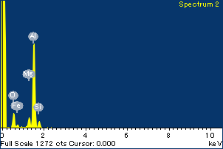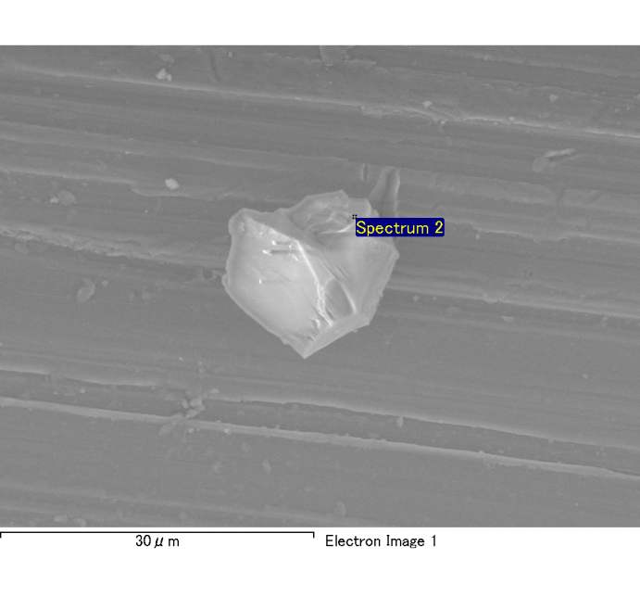

Spectrum Label: Spectrum 2

Livetime 120.0 s

Acquisition geometry ( degrees ):

Tilt = 0.0

Azimuth = 0.0

Elevation = 30.0

Accelerating voltage = 10.00 kV

Total spectrum counts = 118348

|  |  |  |  |
| --- | --- | --- | --- |
| Sample data : | Energy (eV) | Resn. (eV) | Area |
| Strobe : | 3.8 | 53.98 | 1207897 |
|  |  |  |  |
| Optimization data : Cobalt K series |  |  |  |
|  | Energy (eV) | Resn. (eV) | Area |
| Strobe : | .1 | 53.96 | 498142 |
| Optimization element : | 6926.7 | 142.17 | 16696 |

Spectrum processing :

No peaks omitted

Processing option : Oxygen by stoichiometry

Number of iterations = 2

Standard :

Na Albite 1-Jun-1999 12:00 AM

Mg MgO 1-Jun-1999 12:00 AM

Al Al2O3 1-Jun-1999 12:00 AM

Si SiO2 1-Jun-1999 12:00 AM

P GaP 1-Jun-1999 12:00 AM

S FeS2 1-Jun-1999 12:00 AM

K MAD-10 Feldspar 1-Jun-1999 12:00 AM

Ca Wollastonite 1-Jun-1999 12:00 AM

Cr Cr 1-Jun-1999 12:00 AM

Mn Mn 1-Jun-1999 12:00 AM

Fe Fe 1-Jun-1999 12:00 AM

Ni Ni 1-Jun-1999 12:00 AM

|  |  |  |  |  |  |
| --- | --- | --- | --- | --- | --- |
| Element | Weight% | Atomic% | Compd% | Formula |  |
|  |  |  |  |  |  |
| Na K | 0.00 | -0.03 | 0.00 | Na2O |  |
| Mg K | 0.08 | 3.45 | 0.13 | MgO |  |
| Al K | 0.82 | 31.67 | 1.55 | Al2O3 |  |
| Si K | 0.08 | 3.02 | 0.17 | SiO2 |  |
| P K | 0.00 | -0.05 | 0.00 | P2O5 |  |
| S K | 0.00 | 0.11 | 0.01 | SO3 |  |
| K K | 0.00 | -0.04 | 0.00 | K2O |  |
| Ca K | 0.00 | 0.06 | 0.00 | CaO |  |
| Cr K | 0.01 | 0.12 | 0.01 | Cr2O3 |  |
| Mn K | 0.01 | 0.20 | 0.01 | MnO |  |
| Fe K | 0.06 | 1.20 | 0.08 | FeO |  |
| Ni K | 0.04 | 0.75 | 0.05 | NiO |  |
| O | 0.91 | 59.54 |  |  |  |
| Totals | 2.02 |  |  |  |  |

Project: Project 1

Owner: Administrator

Site: Site of Interest 2

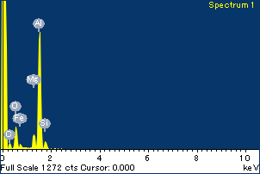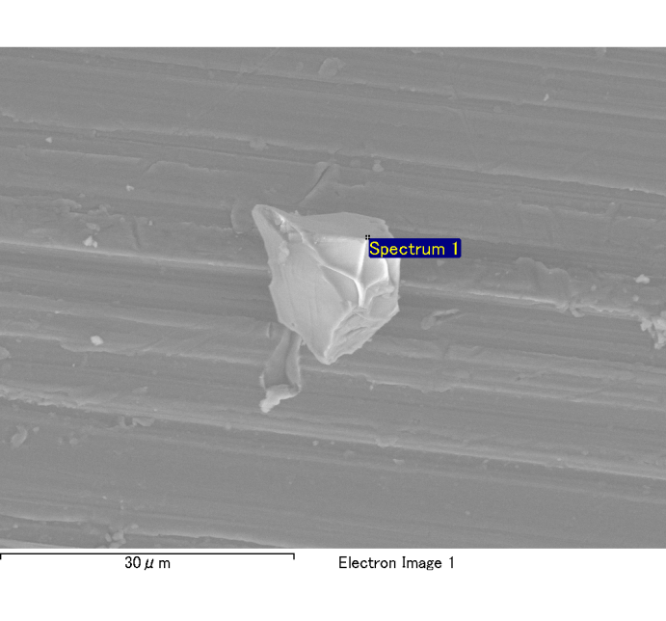

Spectrum Label: Spectrum 1

Livetime 120.0 s

Acquisition geometry ( degrees ):

Tilt = 0.0

Azimuth = 0.0

Elevation = 30.0

Accelerating voltage = 10.00 kV

Total spectrum counts = 121543

|  |  |  |  |
| --- | --- | --- | --- |
| Sample data : | Energy (eV) | Resn. (eV) | Area |
| Strobe : | 3.8 | 54.03 | 1207339 |
|  |  |  |  |
| Optimization data : Cobalt K series |  |  |  |
|  | Energy (eV) | Resn. (eV) | Area |
| Strobe : | .1 | 53.96 | 498142 |
| Optimization element : | 6926.7 | 142.17 | 16696 |

Spectrum processing :

No peaks omitted

Processing option : Oxygen by stoichiometry

Number of iterations = 2

Standard :

Na Albite 1-Jun-1999 12:00 AM

Mg MgO 1-Jun-1999 12:00 AM

Al Al2O3 1-Jun-1999 12:00 AM

Si SiO2 1-Jun-1999 12:00 AM

P GaP 1-Jun-1999 12:00 AM

S FeS2 1-Jun-1999 12:00 AM

K MAD-10 Feldspar 1-Jun-1999 12:00 AM

Ca Wollastonite 1-Jun-1999 12:00 AM

Cr Cr 1-Jun-1999 12:00 AM

Mn Mn 1-Jun-1999 12:00 AM

Fe Fe 1-Jun-1999 12:00 AM

Ni Ni 1-Jun-1999 12:00 AM

|  |  |  |  |  |  |
| --- | --- | --- | --- | --- | --- |
| Element | Weight% | Atomic% | Compd% | Formula |  |
|  |  |  |  |  |  |
| Na K | 0.00 | -0.05 | 0.00 | Na2O |  |
| Mg K | 0.11 | 4.20 | 0.18 | MgO |  |
| Al K | 0.93 | 32.05 | 1.76 | Al2O3 |  |
| Si K | 0.09 | 2.94 | 0.19 | SiO2 |  |
| P K | 0.00 | 0.00 | 0.00 | P2O5 |  |
| S K | 0.00 | -0.02 | 0.00 | SO3 |  |
| K K | 0.00 | 0.08 | 0.00 | K2O |  |
| Ca K | 0.00 | 0.00 | 0.00 | CaO |  |
| Cr K | 0.00 | -0.02 | 0.00 | Cr2O3 |  |
| Mn K | 0.01 | 0.10 | 0.01 | MnO |  |
| Fe K | 0.10 | 1.72 | 0.13 | FeO |  |
| Ni K | -0.03 | -0.47 | -0.04 | NiO |  |
| O | 1.03 | 59.46 |  |  |  |
| Totals | 2.24 |  |  |  |  |

Project: Project 1

Owner: Administrator

Site: Site of Interest 3

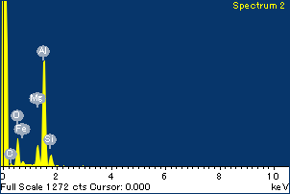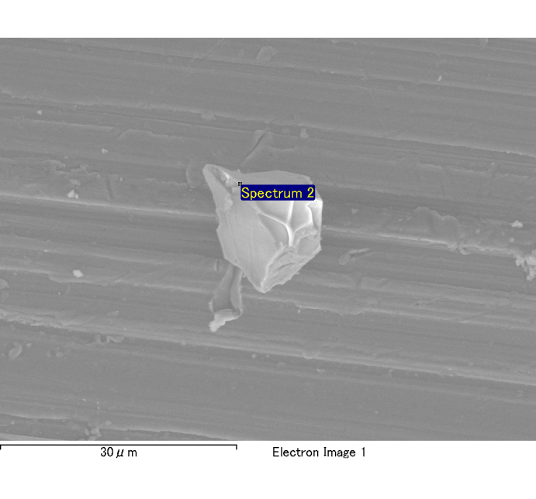

Spectrum Label: Spectrum 2

Livetime 120.0 s

Acquisition geometry ( degrees ):

Tilt = 0.0

Azimuth = 0.0

Elevation = 30.0

Accelerating voltage = 10.00 kV

Total spectrum counts = 119785

|  |  |  |  |
| --- | --- | --- | --- |
| Sample data : | Energy (eV) | Resn. (eV) | Area |
| Strobe : | 3.8 | 54.07 | 1209464 |
|  |  |  |  |
| Optimization data : Cobalt K series |  |  |  |
|  | Energy (eV) | Resn. (eV) | Area |
| Strobe : | .1 | 53.96 | 498142 |
| Optimization element : | 6926.7 | 142.17 | 16696 |

Spectrum processing :

No peaks omitted

Processing option : Oxygen by stoichiometry

Number of iterations = 2

Standard :

Na Albite 1-Jun-1999 12:00 AM

Mg MgO 1-Jun-1999 12:00 AM

Al Al2O3 1-Jun-1999 12:00 AM

Si SiO2 1-Jun-1999 12:00 AM

P GaP 1-Jun-1999 12:00 AM

S FeS2 1-Jun-1999 12:00 AM

K MAD-10 Feldspar 1-Jun-1999 12:00 AM

Ca Wollastonite 1-Jun-1999 12:00 AM

Cr Cr 1-Jun-1999 12:00 AM

Mn Mn 1-Jun-1999 12:00 AM

Fe Fe 1-Jun-1999 12:00 AM

Ni Ni 1-Jun-1999 12:00 AM

|  |  |  |  |  |  |
| --- | --- | --- | --- | --- | --- |
| Element | Weight% | Atomic% | Compd% | Formula |  |
|  |  |  |  |  |  |
| Na K | 0.00 | -0.09 | 0.00 | Na2O |  |
| Mg K | 0.13 | 5.01 | 0.21 | MgO |  |
| Al K | 0.81 | 29.19 | 1.54 | Al2O3 |  |
| Si K | 0.12 | 3.97 | 0.25 | SiO2 |  |
| P K | 0.00 | 0.13 | 0.01 | P2O5 |  |
| S K | 0.00 | -0.06 | -0.01 | SO3 |  |
| K K | 0.00 | 0.07 | 0.00 | K2O |  |
| Ca K | 0.01 | 0.15 | 0.01 | CaO |  |
| Cr K | 0.01 | 0.25 | 0.02 | Cr2O3 |  |
| Mn K | -0.01 | -0.20 | -0.01 | MnO |  |
| Fe K | 0.11 | 1.98 | 0.15 | FeO |  |
| Ni K | 0.01 | 0.23 | 0.02 | NiO |  |
| O | 0.98 | 59.38 |  |  |  |
| Totals | 2.18 |  |  |  |  |

Project: Project 1

Owner: Administrator

Site: Site of Interest 3

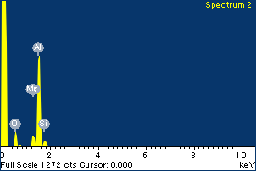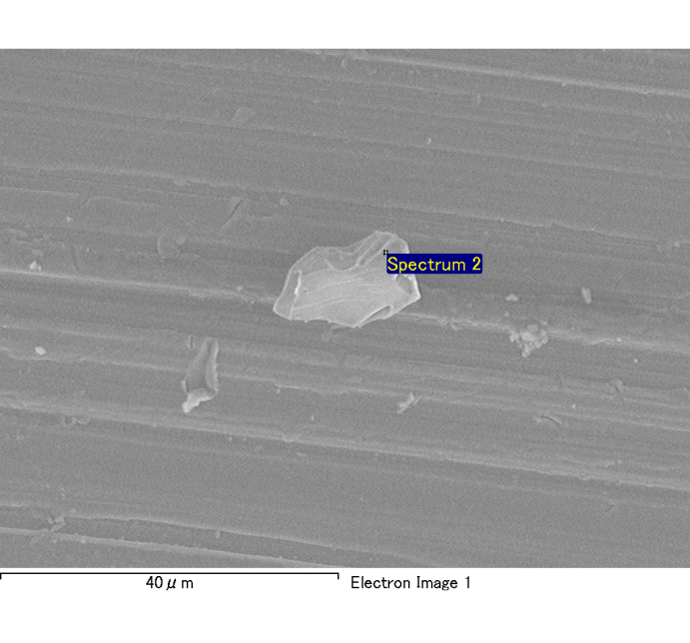

Spectrum Label: Spectrum 2

Livetime 120.0 s

Acquisition geometry ( degrees ):

Tilt = 0.0

Azimuth = 0.0

Elevation = 30.0

Accelerating voltage = 10.00 kV

Total spectrum counts = 116963

|  |  |  |  |
| --- | --- | --- | --- |
| Sample data : | Energy (eV) | Resn. (eV) | Area |
| Strobe : | 3.8 | 53.99 | 1209298 |
|  |  |  |  |
| Optimization data : Cobalt K series |  |  |  |
|  | Energy (eV) | Resn. (eV) | Area |
| Strobe : | .1 | 53.96 | 498142 |
| Optimization element : | 6926.7 | 142.17 | 16696 |

Spectrum processing :

No peaks omitted

Processing option : Oxygen by stoichiometry

Number of iterations = 2

Standard :

Na Albite 1-Jun-1999 12:00 AM

Mg MgO 1-Jun-1999 12:00 AM

Al Al2O3 1-Jun-1999 12:00 AM

Si SiO2 1-Jun-1999 12:00 AM

P GaP 1-Jun-1999 12:00 AM

S FeS2 1-Jun-1999 12:00 AM

K MAD-10 Feldspar 1-Jun-1999 12:00 AM

Ca Wollastonite 1-Jun-1999 12:00 AM

Cr Cr 1-Jun-1999 12:00 AM

Mn Mn 1-Jun-1999 12:00 AM

Fe Fe 1-Jun-1999 12:00 AM

Ni Ni 1-Jun-1999 12:00 AM

|  |  |  |  |  |  |
| --- | --- | --- | --- | --- | --- |
| Element | Weight% | Atomic% | Compd% | Formula |  |
|  |  |  |  |  |  |
| Na K | 0.00 | 0.00 | 0.00 | Na2O |  |
| Mg K | 0.08 | 3.70 | 0.13 | MgO |  |
| Al K | 0.75 | 32.12 | 1.41 | Al2O3 |  |
| Si K | 0.08 | 3.11 | 0.16 | SiO2 |  |
| P K | 0.00 | 0.17 | 0.01 | P2O5 |  |
| S K | 0.00 | 0.04 | 0.00 | SO3 |  |
| K K | 0.00 | -0.12 | 0.00 | K2O |  |
| Ca K | 0.00 | 0.04 | 0.00 | CaO |  |
| Cr K | -0.02 | -0.41 | -0.03 | Cr2O3 |  |
| Mn K | -0.01 | -0.31 | -0.02 | MnO |  |
| Fe K | 0.10 | 2.13 | 0.13 | FeO |  |
| Ni K | -0.01 | -0.14 | -0.01 | NiO |  |
| O | 0.82 | 59.68 |  |  |  |
| Totals | 1.79 |  |  |  |  |

Project: Project 1

Owner: Administrator

Site: Site of Interest 4

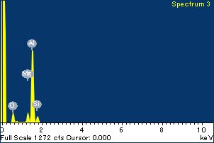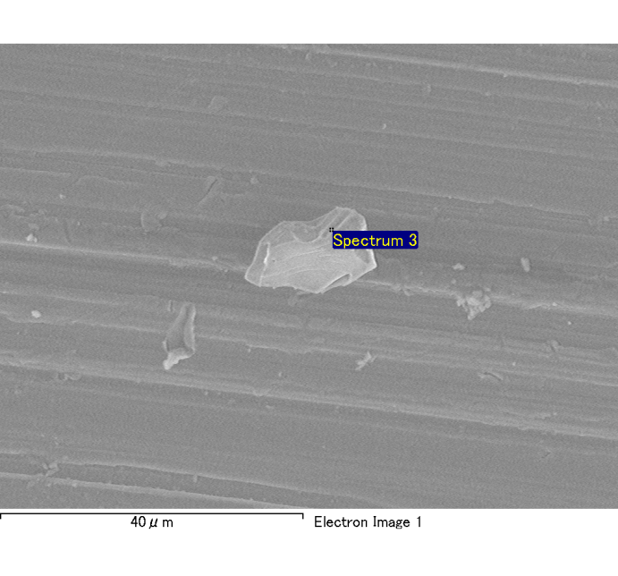

Spectrum Label: Spectrum 3

Livetime 120.0 s

Acquisition geometry ( degrees ):

Tilt = 0.0

Azimuth = 0.0

Elevation = 30.0

Accelerating voltage = 10.00 kV

Total spectrum counts = 116991

|  |  |  |  |
| --- | --- | --- | --- |
| Sample data : | Energy (eV) | Resn. (eV) | Area |
| Strobe : | 3.8 | 53.92 | 1209298 |
|  |  |  |  |
| Optimization data : Cobalt K series |  |  |  |
|  | Energy (eV) | Resn. (eV) | Area |
| Strobe : | .1 | 53.96 | 498142 |
| Optimization element : | 6926.7 | 142.17 | 16696 |

Spectrum processing :

No peaks omitted

Processing option : Oxygen by stoichiometry

Number of iterations = 2

Standard :

Na Albite 1-Jun-1999 12:00 AM

Mg MgO 1-Jun-1999 12:00 AM

Al Al2O3 1-Jun-1999 12:00 AM

Si SiO2 1-Jun-1999 12:00 AM

P GaP 1-Jun-1999 12:00 AM

S FeS2 1-Jun-1999 12:00 AM

K MAD-10 Feldspar 1-Jun-1999 12:00 AM

Ca Wollastonite 1-Jun-1999 12:00 AM

Cr Cr 1-Jun-1999 12:00 AM

Mn Mn 1-Jun-1999 12:00 AM

Fe Fe 1-Jun-1999 12:00 AM

Ni Ni 1-Jun-1999 12:00 AM

|  |  |  |  |  |  |
| --- | --- | --- | --- | --- | --- |
| Element | Weight% | Atomic% | Compd% | Formula |  |
|  |  |  |  |  |  |
| Na K | 0.00 | -0.20 | -0.01 | Na2O |  |
| Mg K | 0.08 | 3.88 | 0.14 | MgO |  |
| Al K | 0.73 | 31.08 | 1.38 | Al2O3 |  |
| Si K | 0.08 | 3.37 | 0.18 | SiO2 |  |
| P K | 0.00 | -0.12 | -0.01 | P2O5 |  |
| S K | 0.00 | 0.07 | 0.01 | SO3 |  |
| K K | 0.00 | 0.00 | 0.00 | K2O |  |
| Ca K | 0.00 | 0.10 | 0.00 | CaO |  |
| Cr K | -0.01 | -0.25 | -0.02 | Cr2O3 |  |
| Mn K | 0.01 | 0.16 | 0.01 | MnO |  |
| Fe K | 0.11 | 2.32 | 0.15 | FeO |  |
| Ni K | 0.01 | 0.14 | 0.01 | NiO |  |
| O | 0.83 | 59.43 |  |  |  |
| Totals | 1.84 |  |  |  |  |

Project: Project 1

Owner: Administrator

Site: Site of Interest 4

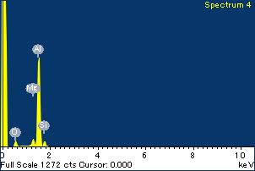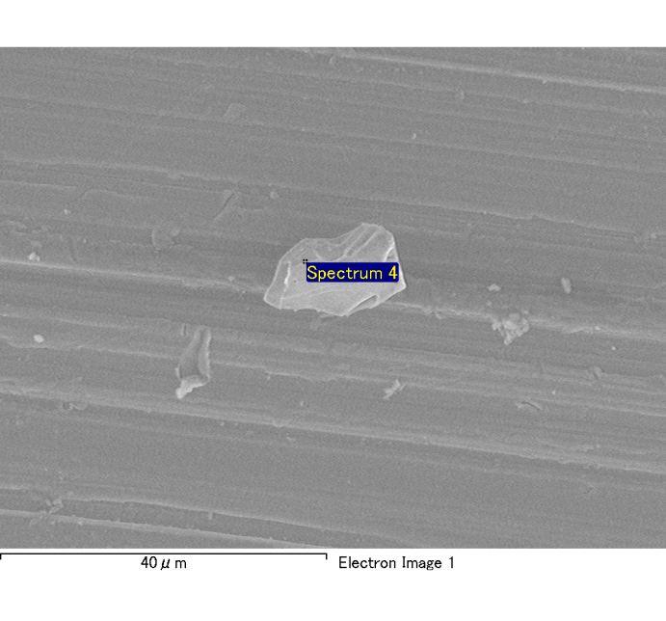

Spectrum Label: Spectrum 4

Livetime 120.0 s

Acquisition geometry ( degrees ):

Tilt = 0.0

Azimuth = 0.0

Elevation = 30.0

Accelerating voltage = 10.00 kV

Total spectrum counts = 115846

|  |  |  |  |
| --- | --- | --- | --- |
| Sample data : | Energy (eV) | Resn. (eV) | Area |
| Strobe : | 3.8 | 53.97 | 1208201 |
|  |  |  |  |
| Optimization data : Cobalt K series |  |  |  |
|  | Energy (eV) | Resn. (eV) | Area |
| Strobe : | .1 | 53.96 | 498142 |
| Optimization element : | 6926.7 | 142.17 | 16696 |

Spectrum processing :

No peaks omitted

Processing option : Oxygen by stoichiometry

Number of iterations = 2

Standard :

Na Albite 1-Jun-1999 12:00 AM

Mg MgO 1-Jun-1999 12:00 AM

Al Al2O3 1-Jun-1999 12:00 AM

Si SiO2 1-Jun-1999 12:00 AM

P GaP 1-Jun-1999 12:00 AM

S FeS2 1-Jun-1999 12:00 AM

K MAD-10 Feldspar 1-Jun-1999 12:00 AM

Ca Wollastonite 1-Jun-1999 12:00 AM

Cr Cr 1-Jun-1999 12:00 AM

Mn Mn 1-Jun-1999 12:00 AM

Fe Fe 1-Jun-1999 12:00 AM

Ni Ni 1-Jun-1999 12:00 AM

|  |  |  |  |  |  |
| --- | --- | --- | --- | --- | --- |
| Element | Weight% | Atomic% | Compd% | Formula |  |
|  |  |  |  |  |  |
| Na K | 0.00 | -0.25 | -0.01 | Na2O |  |
| Mg K | 0.05 | 2.54 | 0.08 | MgO |  |
| Al K | 0.73 | 33.80 | 1.39 | Al2O3 |  |
| Si K | 0.06 | 2.62 | 0.13 | SiO2 |  |
| P K | 0.00 | -0.01 | 0.00 | P2O5 |  |
| S K | 0.00 | -0.01 | 0.00 | SO3 |  |
| K K | 0.00 | -0.07 | 0.00 | K2O |  |
| Ca K | 0.00 | -0.05 | 0.00 | CaO |  |
| Cr K | -0.01 | -0.20 | -0.01 | Cr2O3 |  |
| Mn K | 0.00 | -0.03 | 0.00 | MnO |  |
| Fe K | 0.11 | 2.36 | 0.14 | FeO |  |
| Ni K | -0.02 | -0.46 | -0.03 | NiO |  |
| O | 0.77 | 59.77 |  |  |  |
| Totals | 1.68 |  |  |  |  |

Project: Project 1

Owner: Administrator

Site: Site of Interest 4