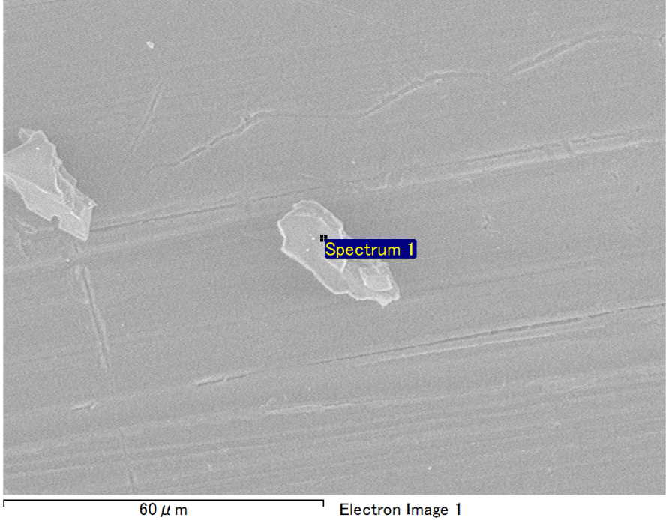

Spectrum Label: Spectrum 1

Livetime 90.0 s

Acquisition geometry ( degrees ):

Tilt = 0.0

Azimuth = 0.0

Elevation = 30.0

Accelerating voltage = 10.00 kV

Total spectrum counts = 65770

|  |  |  |  |
| --- | --- | --- | --- |
| Sample data : | Energy (eV) | Resn. (eV) | Area |
| Strobe : | 3.8 | 53.28 | 917798 |
|  |  |  |  |
| Optimization data : Manganese K series |  |  |  |
|  | Energy (eV) | Resn. (eV) | Area |
| Strobe : | .1 | 53.38 | 1150729 |
| Optimization element : | 5892.6 | 129.89 | 573533 |

Spectrum processing :

No peaks omitted

Processing option : Oxygen by stoichiometry (Normalised)

Number of iterations = 1

Standard :

Mg MgO 1-Jun-1999 12:00 AM

Al Al2O3 1-Jun-1999 12:00 AM

Si SiO2 1-Jun-1999 12:00 AM

|  |  |  |  |  |  |
| --- | --- | --- | --- | --- | --- |
| Element | Weight% | Atomic% | Compd% | Formula |  |
|  |  |  |  |  |  |
| Mg K | 3.34 | 2.79 | 5.54 | MgO |  |
| Al K | 42.78 | 32.23 | 80.83 | Al2O3 |  |
| Si K | 6.37 | 4.61 | 13.63 | SiO2 |  |
| O | 47.51 | 60.36 |  |  |  |
| Totals | 100.00 |  |  |  |  |

Project: Project 1

Owner: Operator

Site: Site of Interest 6

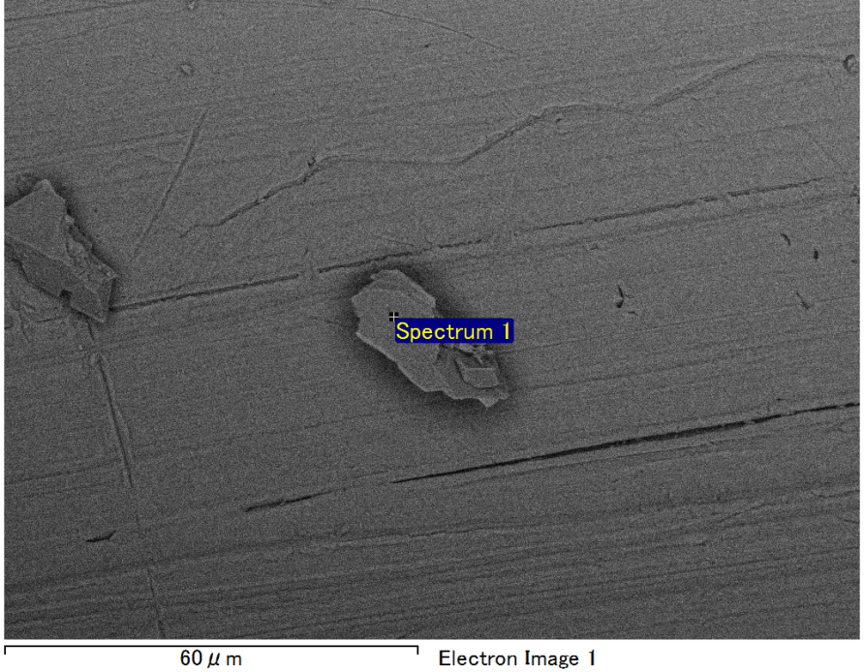

Spectrum Label: Spectrum 1

Livetime 90.0 s

Acquisition geometry ( degrees ):

Tilt = 0.0

Azimuth = 0.0

Elevation = 30.0

Accelerating voltage = 10.00 kV

Total spectrum counts = 65459

|  |  |  |  |
| --- | --- | --- | --- |
| Sample data : | Energy (eV) | Resn. (eV) | Area |
| Strobe : | 3.8 | 53.26 | 919047 |
|  |  |  |  |
| Optimization data : Manganese K series |  |  |  |
|  | Energy (eV) | Resn. (eV) | Area |
| Strobe : | .1 | 53.38 | 1150729 |
| Optimization element : | 5892.6 | 129.89 | 573533 |

Spectrum processing :

No peaks omitted

Processing option : Oxygen by stoichiometry (Normalised)

Number of iterations = 1

Standard :

Mg MgO 1-Jun-1999 12:00 AM

Al Al2O3 1-Jun-1999 12:00 AM

Si SiO2 1-Jun-1999 12:00 AM

|  |  |  |  |  |  |
| --- | --- | --- | --- | --- | --- |
| Element | Weight% | Atomic% | Compd% | Formula |  |
|  |  |  |  |  |  |
| Mg K | 2.99 | 2.50 | 4.96 | MgO |  |
| Al K | 43.97 | 33.14 | 83.08 | Al2O3 |  |
| Si K | 5.59 | 4.05 | 11.96 | SiO2 |  |
| O | 47.45 | 60.31 |  |  |  |
| Totals | 100.00 |  |  |  |  |

Project: Project 1

Owner: Operator

Site: Site of Interest 7

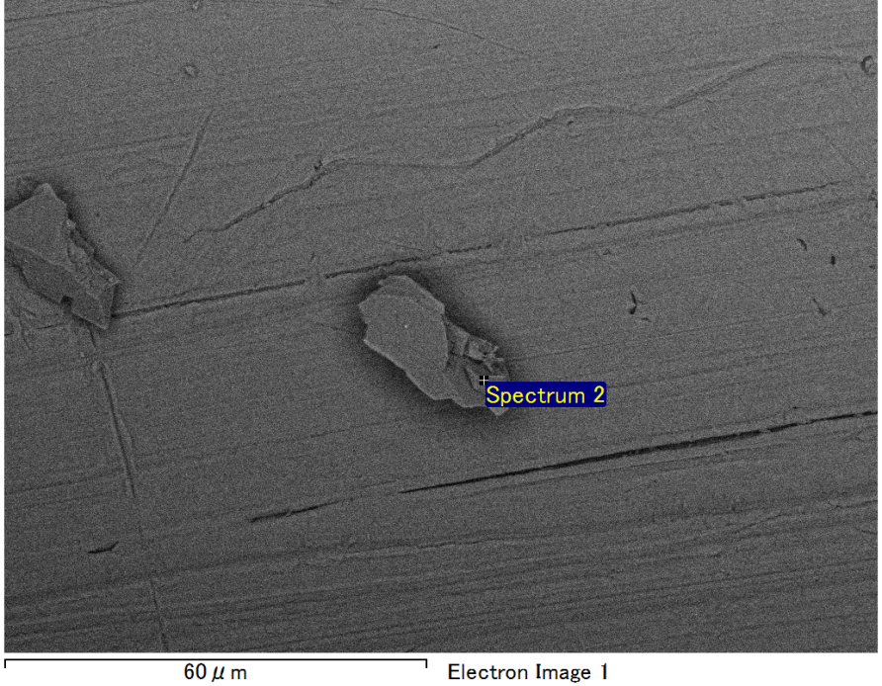

Spectrum Label: Spectrum 2

Livetime 90.0 s

Acquisition geometry ( degrees ):

Tilt = 0.0

Azimuth = 0.0

Elevation = 30.0

Accelerating voltage = 10.00 kV

Total spectrum counts = 65715

|  |  |  |  |
| --- | --- | --- | --- |
| Sample data : | Energy (eV) | Resn. (eV) | Area |
| Strobe : | 3.8 | 53.22 | 919556 |
|  |  |  |  |
| Optimization data : Manganese K series |  |  |  |
|  | Energy (eV) | Resn. (eV) | Area |
| Strobe : | .1 | 53.38 | 1150729 |
| Optimization element : | 5892.6 | 129.89 | 573533 |

Spectrum processing :

No peaks omitted

Processing option : Oxygen by stoichiometry (Normalised)

Number of iterations = 1

Standard :

Mg MgO 1-Jun-1999 12:00 AM

Al Al2O3 1-Jun-1999 12:00 AM

Si SiO2 1-Jun-1999 12:00 AM

|  |  |  |  |  |  |
| --- | --- | --- | --- | --- | --- |
| Element | Weight% | Atomic% | Compd% | Formula |  |
|  |  |  |  |  |  |
| Mg K | 3.41 | 2.85 | 5.66 | MgO |  |
| Al K | 42.99 | 32.39 | 81.22 | Al2O3 |  |
| Si K | 6.13 | 4.44 | 13.12 | SiO2 |  |
| O | 47.47 | 60.32 |  |  |  |
| Totals | 100.00 |  |  |  |  |

Project: Project 1

Owner: Operator

Site: Site of Interest 7

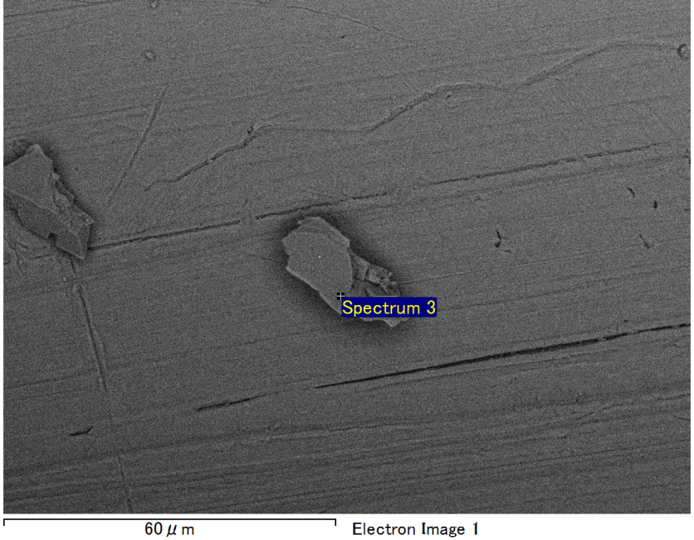

Spectrum Label: Spectrum 3

Livetime 90.0 s

Acquisition geometry ( degrees ):

Tilt = 0.0

Azimuth = 0.0

Elevation = 30.0

Accelerating voltage = 10.00 kV

Total spectrum counts = 65826

|  |  |  |  |
| --- | --- | --- | --- |
| Sample data : | Energy (eV) | Resn. (eV) | Area |
| Strobe : | 3.8 | 53.19 | 918662 |
|  |  |  |  |
| Optimization data : Manganese K series |  |  |  |
|  | Energy (eV) | Resn. (eV) | Area |
| Strobe : | .1 | 53.38 | 1150729 |
| Optimization element : | 5892.6 | 129.89 | 573533 |

Spectrum processing :

Peak possibly omitted : 0.715 keV

Processing option : Oxygen by stoichiometry (Normalised)

Number of iterations = 1

Standard :

Mg MgO 1-Jun-1999 12:00 AM

Al Al2O3 1-Jun-1999 12:00 AM

Si SiO2 1-Jun-1999 12:00 AM

|  |  |  |  |  |  |
| --- | --- | --- | --- | --- | --- |
| Element | Weight% | Atomic% | Compd% | Formula |  |
|  |  |  |  |  |  |
| Mg K | 3.59 | 3.00 | 5.95 | MgO |  |
| Al K | 42.53 | 32.04 | 80.36 | Al2O3 |  |
| Si K | 6.40 | 4.63 | 13.69 | SiO2 |  |
| O | 47.48 | 60.33 |  |  |  |
| Totals | 100.00 |  |  |  |  |

Project: Project 1

Owner: Operator

Site: Site of Interest 7

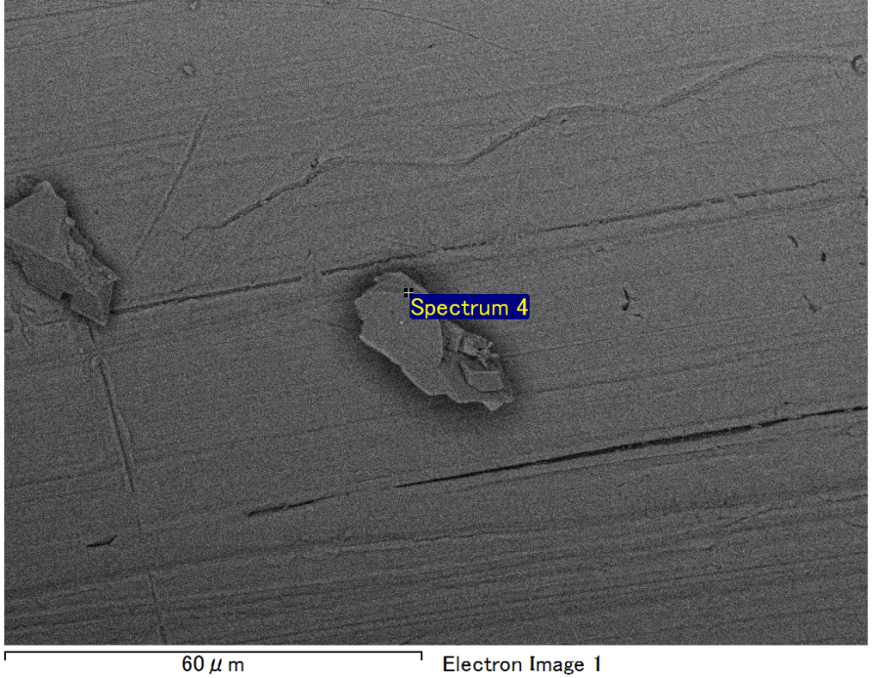

Spectrum Label: Spectrum 4

Livetime 90.0 s

Acquisition geometry ( degrees ):

Tilt = 0.0

Azimuth = 0.0

Elevation = 30.0

Accelerating voltage = 10.00 kV

Total spectrum counts = 66629

|  |  |  |  |
| --- | --- | --- | --- |
| Sample data : | Energy (eV) | Resn. (eV) | Area |
| Strobe : | 3.8 | 53.27 | 919542 |
|  |  |  |  |
| Optimization data : Manganese K series |  |  |  |
|  | Energy (eV) | Resn. (eV) | Area |
| Strobe : | .1 | 53.38 | 1150729 |
| Optimization element : | 5892.6 | 129.89 | 573533 |

Spectrum processing :

No peaks omitted

Processing option : Oxygen by stoichiometry (Normalised)

Number of iterations = 1

Standard :

Mg MgO 1-Jun-1999 12:00 AM

Al Al2O3 1-Jun-1999 12:00 AM

Si SiO2 1-Jun-1999 12:00 AM

|  |  |  |  |  |  |
| --- | --- | --- | --- | --- | --- |
| Element | Weight% | Atomic% | Compd% | Formula |  |
|  |  |  |  |  |  |
| Mg K | 3.86 | 3.23 | 6.41 | MgO |  |
| Al K | 41.80 | 31.48 | 78.98 | Al2O3 |  |
| Si K | 6.83 | 4.94 | 14.62 | SiO2 |  |
| O | 47.50 | 60.34 |  |  |  |
| Totals | 100.00 |  |  |  |  |

Project: Project 1

Owner: Operator

Site: Site of Interest 7