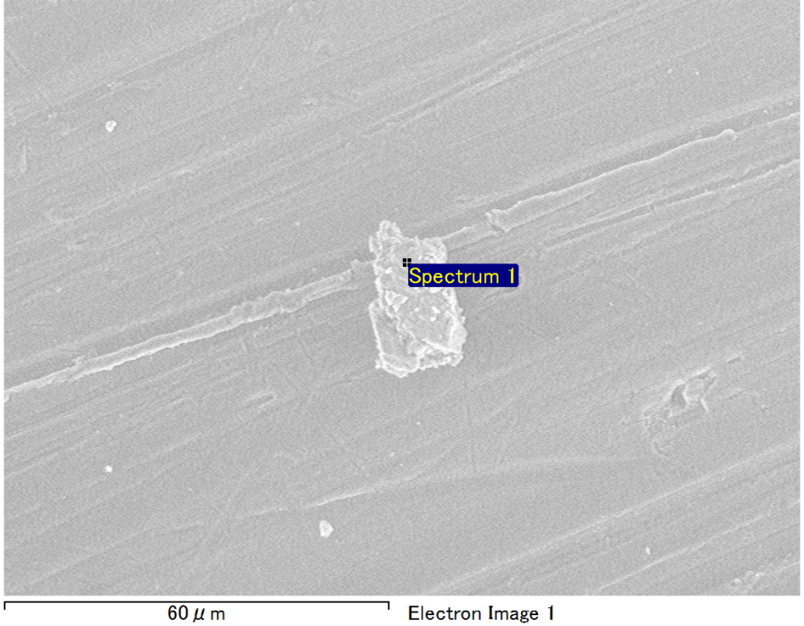

Spectrum Label: Spectrum 1

Livetime 90.0 s

Acquisition geometry ( degrees ):

Tilt = 0.0

Azimuth = 0.0

Elevation = 30.0

Accelerating voltage = 10.00 kV

Total spectrum counts = 65298

|  |  |  |  |
| --- | --- | --- | --- |
| Sample data : | Energy (eV) | Resn. (eV) | Area |
| Strobe : | 3.8 | 53.31 | 917858 |
|  |  |  |  |
| Optimization data : Manganese K series |  |  |  |
|  | Energy (eV) | Resn. (eV) | Area |
| Strobe : | .1 | 53.38 | 1150729 |
| Optimization element : | 5892.6 | 129.89 | 573533 |

Spectrum processing :

No peaks omitted

Processing option : Oxygen by stoichiometry (Normalised)

Number of iterations = 1

Standard :

Mg MgO 1-Jun-1999 12:00 AM

Al Al2O3 1-Jun-1999 12:00 AM

Si SiO2 1-Jun-1999 12:00 AM

|  |  |  |  |  |  |
| --- | --- | --- | --- | --- | --- |
| Element | Weight% | Atomic% | Compd% | Formula |  |
|  |  |  |  |  |  |
| Mg K | 3.18 | 2.66 | 5.28 | MgO |  |
| Al K | 46.36 | 34.97 | 87.59 | Al2O3 |  |
| Si K | 3.33 | 2.41 | 7.13 | SiO2 |  |
| O | 47.12 | 59.95 |  |  |  |
| Totals | 100.00 |  |  |  |  |

Project: Project 1

Owner: Operator

Site: Site of Interest 13

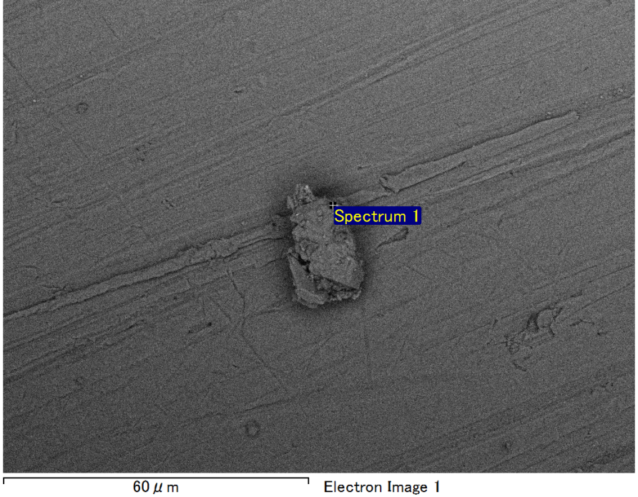

Spectrum Label: Spectrum 1

Livetime 90.0 s

Acquisition geometry ( degrees ):

Tilt = 0.0

Azimuth = 0.0

Elevation = 30.0

Accelerating voltage = 10.00 kV

Total spectrum counts = 67446

|  |  |  |  |
| --- | --- | --- | --- |
| Sample data : | Energy (eV) | Resn. (eV) | Area |
| Strobe : | 3.8 | 53.20 | 918556 |
|  |  |  |  |
| Optimization data : Manganese K series |  |  |  |
|  | Energy (eV) | Resn. (eV) | Area |
| Strobe : | .1 | 53.38 | 1150729 |
| Optimization element : | 5892.6 | 129.89 | 573533 |

Spectrum processing :

No peaks omitted

Processing option : Oxygen by stoichiometry (Normalised)

Number of iterations = 1

Standard :

Mg MgO 1-Jun-1999 12:00 AM

Al Al2O3 1-Jun-1999 12:00 AM

Si SiO2 1-Jun-1999 12:00 AM

Fe Fe 1-Jun-1999 12:00 AM

|  |  |  |  |  |  |
| --- | --- | --- | --- | --- | --- |
| Element | Weight% | Atomic% | Compd% | Formula |  |
|  |  |  |  |  |  |
| Mg K | 3.49 | 3.10 | 5.79 | MgO |  |
| Al K | 39.72 | 31.75 | 75.04 | Al2O3 |  |
| Si K | 2.88 | 2.21 | 6.16 | SiO2 |  |
| Fe L | 10.11 | 3.90 | 13.01 | FeO |  |
| O | 43.80 | 59.04 |  |  |  |
| Totals | 100.00 |  |  |  |  |

Project: Project 1

Owner: Operator

Site: Site of Interest 14

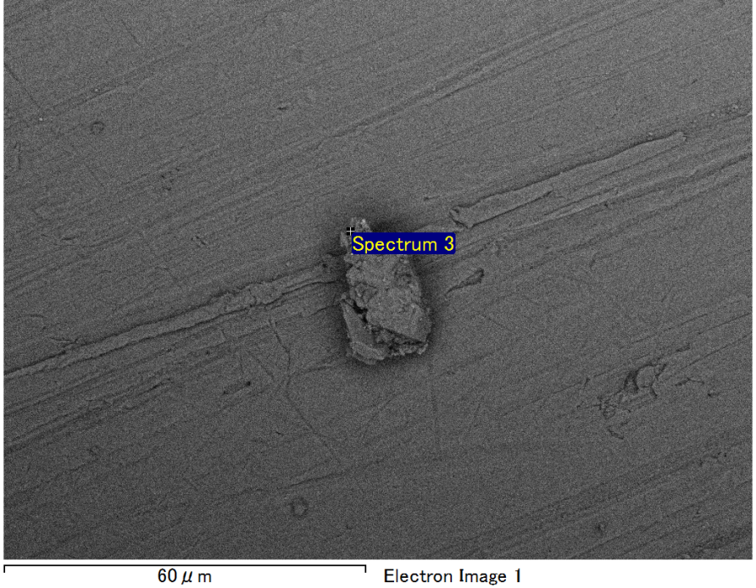

Spectrum Label: Spectrum 3

Livetime 90.0 s

Acquisition geometry ( degrees ):

Tilt = 0.0

Azimuth = 0.0

Elevation = 30.0

Accelerating voltage = 10.00 kV

Total spectrum counts = 66083

|  |  |  |  |
| --- | --- | --- | --- |
| Sample data : | Energy (eV) | Resn. (eV) | Area |
| Strobe : | 3.8 | 53.15 | 919026 |
|  |  |  |  |
| Optimization data : Manganese K series |  |  |  |
|  | Energy (eV) | Resn. (eV) | Area |
| Strobe : | .1 | 53.38 | 1150729 |
| Optimization element : | 5892.6 | 129.89 | 573533 |

Spectrum processing :

No peaks omitted

Processing option : Oxygen by stoichiometry (Normalised)

Number of iterations = 1

Standard :

Mg MgO 1-Jun-1999 12:00 AM

Al Al2O3 1-Jun-1999 12:00 AM

Si SiO2 1-Jun-1999 12:00 AM

|  |  |  |  |  |  |
| --- | --- | --- | --- | --- | --- |
| Element | Weight% | Atomic% | Compd% | Formula |  |
|  |  |  |  |  |  |
| Mg K | 3.16 | 2.64 | 5.24 | MgO |  |
| Al K | 45.27 | 34.14 | 85.54 | Al2O3 |  |
| Si K | 4.31 | 3.13 | 9.23 | SiO2 |  |
| O | 47.26 | 60.10 |  |  |  |
| Totals | 100.00 |  |  |  |  |

Project: Project 1

Owner: Operator

Site: Site of Interest 14

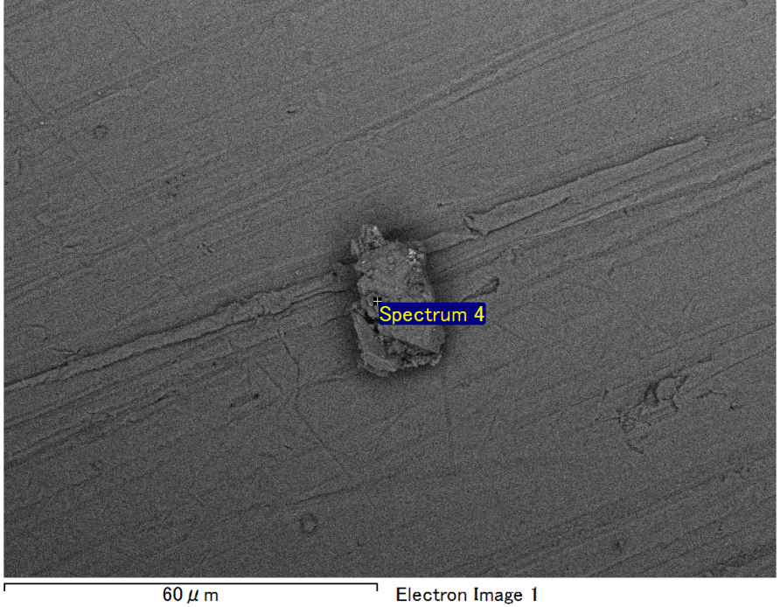

Spectrum Label: Spectrum 4

Livetime 90.0 s

Acquisition geometry ( degrees ):

Tilt = 0.0

Azimuth = 0.0

Elevation = 30.0

Accelerating voltage = 10.00 kV

Total spectrum counts = 66133

|  |  |  |  |
| --- | --- | --- | --- |
| Sample data : | Energy (eV) | Resn. (eV) | Area |
| Strobe : | 3.8 | 53.21 | 917939 |
|  |  |  |  |
| Optimization data : Manganese K series |  |  |  |
|  | Energy (eV) | Resn. (eV) | Area |
| Strobe : | .1 | 53.38 | 1150729 |
| Optimization element : | 5892.6 | 129.89 | 573533 |

Spectrum processing :

No peaks omitted

Processing option : Oxygen by stoichiometry (Normalised)

Number of iterations = 1

Standard :

Mg MgO 1-Jun-1999 12:00 AM

Al Al2O3 1-Jun-1999 12:00 AM

Si SiO2 1-Jun-1999 12:00 AM

|  |  |  |  |  |  |
| --- | --- | --- | --- | --- | --- |
| Element | Weight% | Atomic% | Compd% | Formula |  |
|  |  |  |  |  |  |
| Mg K | 1.33 | 1.11 | 2.21 | MgO |  |
| Al K | 44.09 | 33.23 | 83.31 | Al2O3 |  |
| Si K | 6.77 | 4.90 | 14.48 | SiO2 |  |
| O | 47.81 | 60.76 |  |  |  |
| Totals | 100.00 |  |  |  |  |

Project: Project 1

Owner: Operator

Site: Site of Interest 14

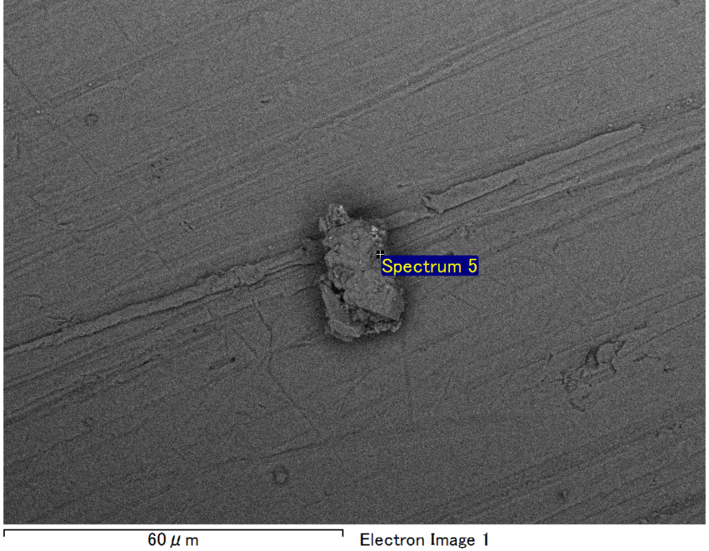

Spectrum Label: Spectrum 5

Livetime 90.0 s

Acquisition geometry ( degrees ):

Tilt = 0.0

Azimuth = 0.0

Elevation = 30.0

Accelerating voltage = 10.00 kV

Total spectrum counts = 66843

|  |  |  |  |
| --- | --- | --- | --- |
| Sample data : | Energy (eV) | Resn. (eV) | Area |
| Strobe : | 3.8 | 53.29 | 918303 |
|  |  |  |  |
| Optimization data : Manganese K series |  |  |  |
|  | Energy (eV) | Resn. (eV) | Area |
| Strobe : | .1 | 53.38 | 1150729 |
| Optimization element : | 5892.6 | 129.89 | 573533 |

Spectrum processing :

No peaks omitted

Processing option : Oxygen by stoichiometry (Normalised)

Number of iterations = 1

Standard :

Na Albite 1-Jun-1999 12:00 AM

Mg MgO 1-Jun-1999 12:00 AM

Al Al2O3 1-Jun-1999 12:00 AM

Si SiO2 1-Jun-1999 12:00 AM

|  |  |  |  |  |  |
| --- | --- | --- | --- | --- | --- |
| Element | Weight% | Atomic% | Compd% | Formula |  |
|  |  |  |  |  |  |
| Na K | 0.80 | 0.71 | 1.08 | Na2O |  |
| Mg K | 0.85 | 0.71 | 1.40 | MgO |  |
| Al K | 43.29 | 32.62 | 81.79 | Al2O3 |  |
| Si K | 7.35 | 5.32 | 15.73 | SiO2 |  |
| O | 47.71 | 60.64 |  |  |  |
| Totals | 100.00 |  |  |  |  |

Project: Project 1

Owner: Operator

Site: Site of Interest 14