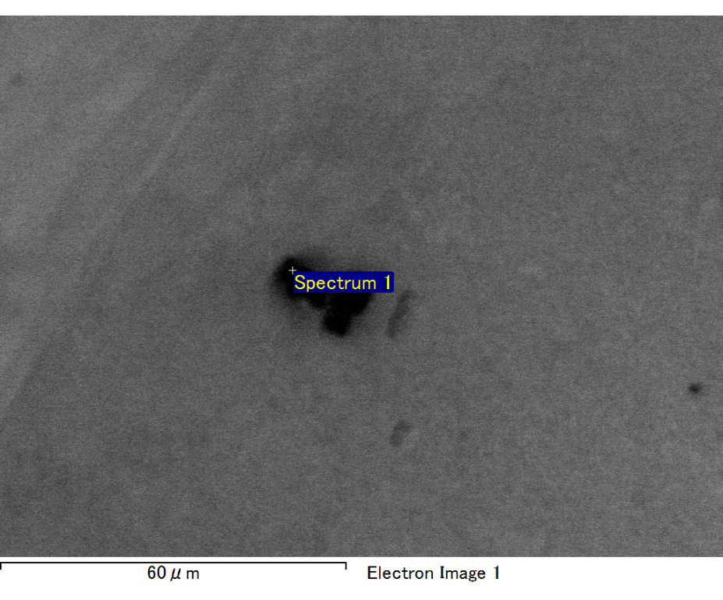

Spectrum processing :

No peaks omitted

Processing option : All elements analyzed (Normalised)

Number of iterations = 2

Standard :

C CaCO3 1-Jun-1999 12:00 AM

O SiO2 1-Jun-1999 12:00 AM

Mg MgO 1-Jun-1999 12:00 AM

Si SiO2 1-Jun-1999 12:00 AM

Fe Fe 1-Jun-1999 12:00 AM

Au Au 1-Jun-1999 12:00 AM

|  |  |  |  |
| --- | --- | --- | --- |
| Element | Weight% | Atomic% |  |
|  |  |  |  |
| C K | 2.39 | 7.74 |  |
| O K | 23.05 | 56.19 |  |
| Mg K | 7.20 | 11.55 |  |
| Si K | 4.38 | 6.08 |  |
| Fe L | 11.92 | 8.32 |  |
| Au M | 51.06 | 10.11 |  |
|  |  |  |  |
| Totals | 100.00 |  |  |

Spectrum Label: Spectrum 1

Livetime 60.0 s

Acquisition geometry ( degrees ):

Tilt = 15.0

Azimuth = 0.0

Elevation = 30.0

Accelerating voltage = 10.00 kV

Total spectrum counts = 48586

|  |  |  |  |
| --- | --- | --- | --- |
| Sample data : | Energy (eV) | Resn. (eV) | Area |
| Strobe : | 3.8 | 47.19 | 1000159 |
|  |  |  |  |

No quant optimization performed

Sample: Sample 1

Type: Default

ID:

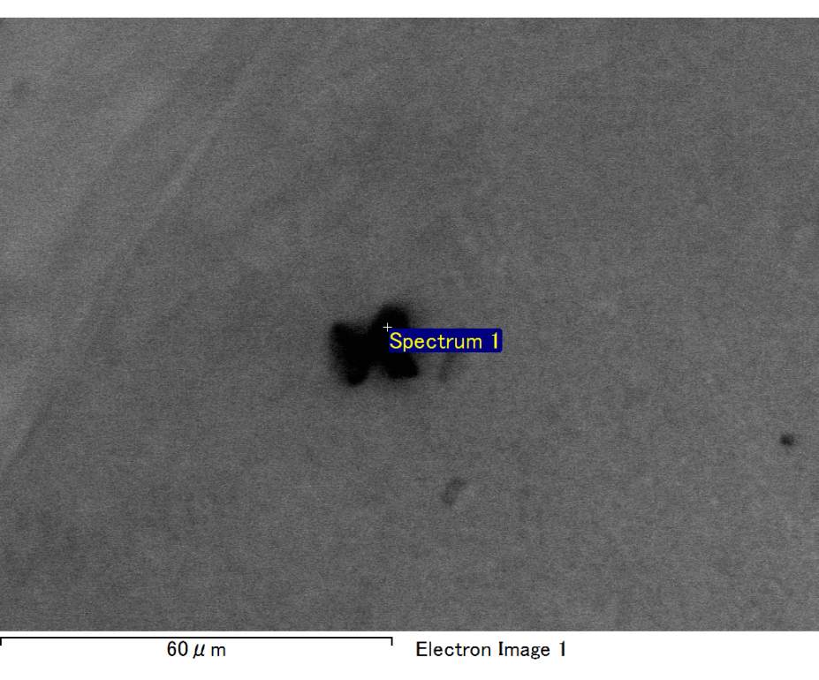

Spectrum processing :

No peaks omitted

Processing option : All elements analyzed (Normalised)

Number of iterations = 2

Standard :

C CaCO3 1-Jun-1999 12:00 AM

O SiO2 1-Jun-1999 12:00 AM

Mg MgO 1-Jun-1999 12:00 AM

P GaP 1-Jun-1999 12:00 AM

Cl KCl 1-Jun-1999 12:00 AM

Ca Wollastonite 1-Jun-1999 12:00 AM

Au Au 1-Jun-1999 12:00 AM

|  |  |  |  |
| --- | --- | --- | --- |
| Element | Weight% | Atomic% |  |
|  |  |  |  |
| C K | 2.98 | 12.02 |  |
| O K | 14.65 | 44.31 |  |
| Mg K | 0.86 | 1.72 |  |
| P K | 5.90 | 9.22 |  |
| Cl K | 2.32 | 3.17 |  |
| Ca K | 12.00 | 14.50 |  |
| Au M | 61.29 | 15.06 |  |
|  |  |  |  |
| Totals | 100.00 |  |  |

Spectrum Label: Spectrum 1

Livetime 60.0 s

Acquisition geometry ( degrees ):

Tilt = 15.0

Azimuth = 0.0

Elevation = 30.0

Accelerating voltage = 10.00 kV

Total spectrum counts = 43934

|  |  |  |  |
| --- | --- | --- | --- |
| Sample data : | Energy (eV) | Resn. (eV) | Area |
| Strobe : | 3.8 | 47.20 | 1000026 |
|  |  |  |  |

No quant optimization performed

Sample: Sample 1

Type: Default

ID:

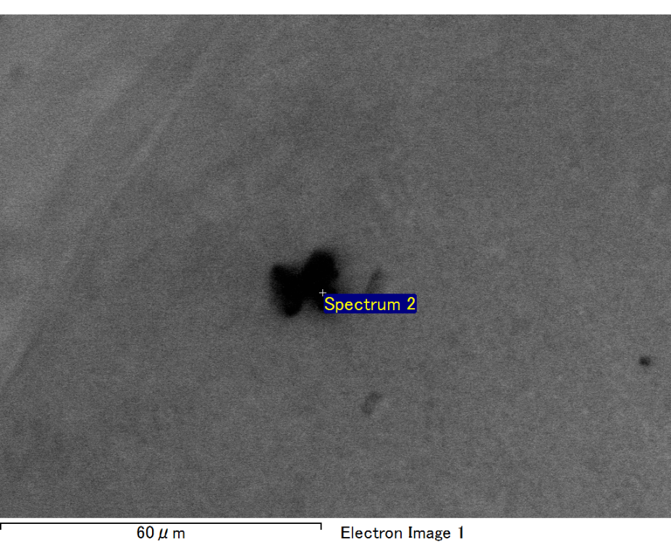

Spectrum processing :

No peaks omitted

Processing option : All elements analyzed (Normalised)

Number of iterations = 2

Standard :

C CaCO3 1-Jun-1999 12:00 AM

O SiO2 1-Jun-1999 12:00 AM

Ca Wollastonite 1-Jun-1999 12:00 AM

Au Au 1-Jun-1999 12:00 AM

|  |  |  |  |
| --- | --- | --- | --- |
| Element | Weight% | Atomic% |  |
|  |  |  |  |
| C K | 3.15 | 26.70 |  |
| O K | 2.16 | 13.75 |  |
| Ca K | 5.25 | 13.34 |  |
| Au M | 89.43 | 46.21 |  |
|  |  |  |  |
| Totals | 100.00 |  |  |

Spectrum Label: Spectrum 2

Livetime 60.0 s

Acquisition geometry ( degrees ):

Tilt = 15.0

Azimuth = 0.0

Elevation = 30.0

Accelerating voltage = 10.00 kV

Total spectrum counts = 42446

|  |  |  |  |
| --- | --- | --- | --- |
| Sample data : | Energy (eV) | Resn. (eV) | Area |
| Strobe : | 3.8 | 47.30 | 999764 |
|  |  |  |  |

No quant optimization performed

Sample: Sample 1

Type: Default

ID:

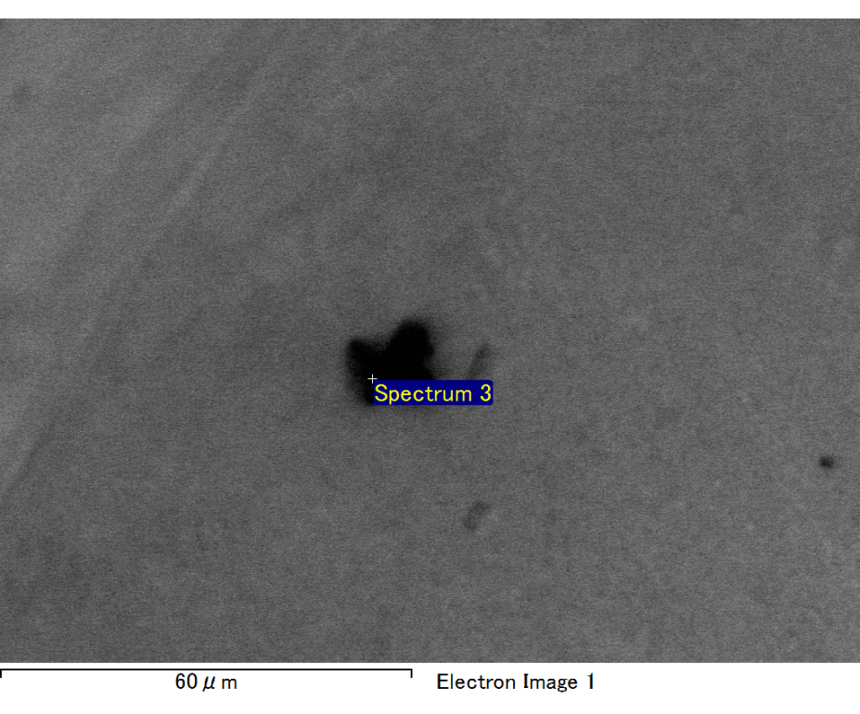

Spectrum processing :

No peaks omitted

Processing option : All elements analyzed (Normalised)

Number of iterations = 2

Standard :

C CaCO3 1-Jun-1999 12:00 AM

O SiO2 1-Jun-1999 12:00 AM

Mg MgO 1-Jun-1999 12:00 AM

Si SiO2 1-Jun-1999 12:00 AM

Fe Fe 1-Jun-1999 12:00 AM

Au Au 1-Jun-1999 12:00 AM

|  |  |  |  |
| --- | --- | --- | --- |
| Element | Weight% | Atomic% |  |
|  |  |  |  |
| C K | 3.00 | 16.98 |  |
| O K | 8.66 | 36.76 |  |
| Mg K | 3.05 | 8.53 |  |
| Si K | 2.85 | 6.88 |  |
| Fe L | 2.79 | 3.39 |  |
| Au M | 79.65 | 27.45 |  |
|  |  |  |  |
| Totals | 100.00 |  |  |

Spectrum Label: Spectrum 3

Livetime 60.0 s

Acquisition geometry ( degrees ):

Tilt = 15.0

Azimuth = 0.0

Elevation = 30.0

Accelerating voltage = 10.00 kV

Total spectrum counts = 42115

|  |  |  |  |
| --- | --- | --- | --- |
| Sample data : | Energy (eV) | Resn. (eV) | Area |
| Strobe : | 3.8 | 47.22 | 1000647 |
|  |  |  |  |

No quant optimization performed

Sample: Sample 1

Type: Default

ID:

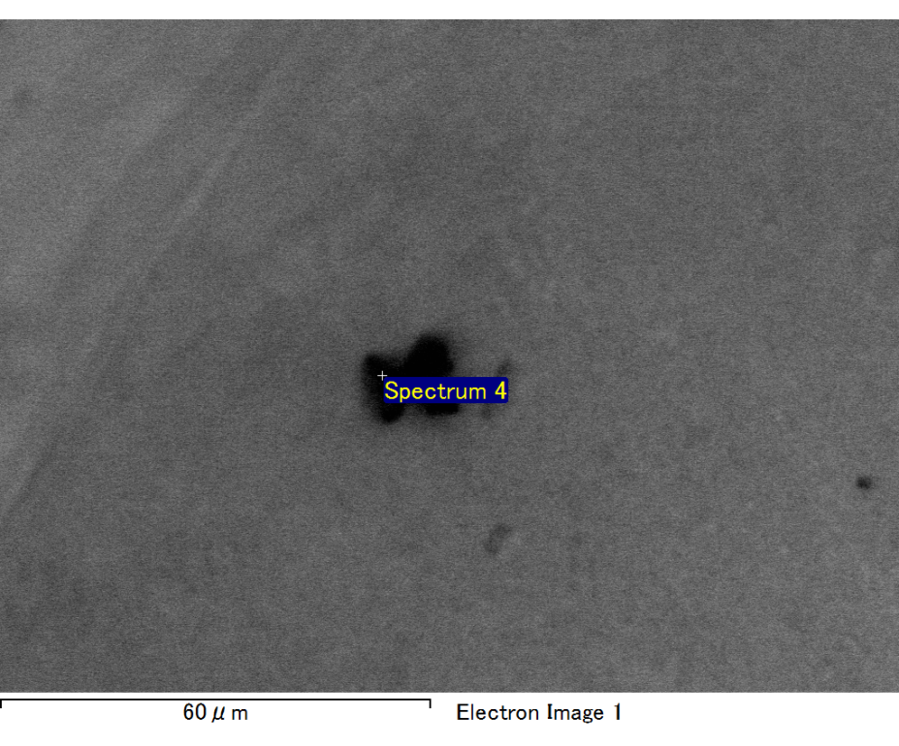

Spectrum processing :

No peaks omitted

Processing option : All elements analyzed (Normalised)

Number of iterations = 2

Standard :

C CaCO3 1-Jun-1999 12:00 AM

O SiO2 1-Jun-1999 12:00 AM

Mg MgO 1-Jun-1999 12:00 AM

Si SiO2 1-Jun-1999 12:00 AM

Fe Fe 1-Jun-1999 12:00 AM

Au Au 1-Jun-1999 12:00 AM

|  |  |  |  |
| --- | --- | --- | --- |
| Element | Weight% | Atomic% |  |
|  |  |  |  |
| C K | 2.04 | 6.70 |  |
| O K | 23.59 | 58.16 |  |
| Mg K | 6.30 | 10.22 |  |
| Si K | 4.69 | 6.58 |  |
| Fe L | 11.14 | 7.87 |  |
| Au M | 52.26 | 10.47 |  |
|  |  |  |  |
| Totals | 100.00 |  |  |

Spectrum Label: Spectrum 4

Livetime 60.0 s

Acquisition geometry ( degrees ):

Tilt = 15.0

Azimuth = 0.0

Elevation = 30.0

Accelerating voltage = 10.00 kV

Total spectrum counts = 48573

|  |  |  |  |
| --- | --- | --- | --- |
| Sample data : | Energy (eV) | Resn. (eV) | Area |
| Strobe : | 3.8 | 47.23 | 1000305 |
|  |  |  |  |

No quant optimization performed

Sample: Sample 1

Type: Default

ID: