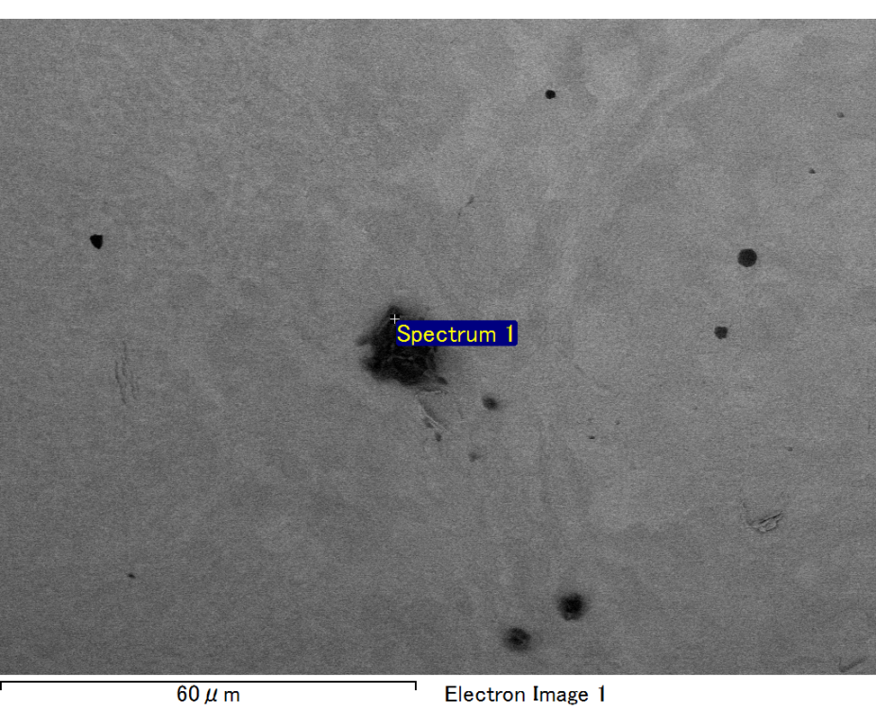

Spectrum processing :

No peaks omitted

Processing option : All elements analyzed (Normalised)

Number of iterations = 2

Standard :

C CaCO3 1-Jun-1999 12:00 AM

O SiO2 1-Jun-1999 12:00 AM

Mg MgO 1-Jun-1999 12:00 AM

Si SiO2 1-Jun-1999 12:00 AM

Fe Fe 1-Jun-1999 12:00 AM

Au Au 1-Jun-1999 12:00 AM

|  |  |  |  |
| --- | --- | --- | --- |
| Element | Weight% | Atomic% |  |
|  |  |  |  |
| C K | 2.74 | 9.69 |  |
| O K | 20.61 | 54.64 |  |
| Mg K | 5.81 | 10.13 |  |
| Si K | 3.97 | 6.00 |  |
| Fe L | 9.46 | 7.19 |  |
| Au M | 57.40 | 12.36 |  |
|  |  |  |  |
| Totals | 100.00 |  |  |

Spectrum Label: Spectrum 1

Livetime 60.0 s

Acquisition geometry ( degrees ):

Tilt = 15.0

Azimuth = 0.0

Elevation = 30.0

Accelerating voltage = 10.00 kV

Total spectrum counts = 53689

|  |  |  |  |
| --- | --- | --- | --- |
| Sample data : | Energy (eV) | Resn. (eV) | Area |
| Strobe : | 3.8 | 47.22 | 1000782 |
|  |  |  |  |

No quant optimization performed

Sample: Sample 1

Type: Default

ID:

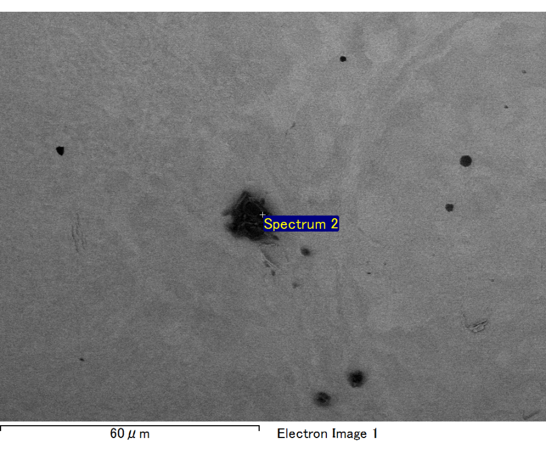

Spectrum processing :

No peaks omitted

Processing option : All elements analyzed (Normalised)

Number of iterations = 2

Standard :

C CaCO3 1-Jun-1999 12:00 AM

O SiO2 1-Jun-1999 12:00 AM

Mg MgO 1-Jun-1999 12:00 AM

Si SiO2 1-Jun-1999 12:00 AM

Fe Fe 1-Jun-1999 12:00 AM

Au Au 1-Jun-1999 12:00 AM

|  |  |  |  |
| --- | --- | --- | --- |
| Element | Weight% | Atomic% |  |
|  |  |  |  |
| C K | 3.34 | 12.38 |  |
| O K | 18.19 | 50.68 |  |
| Mg K | 5.24 | 9.61 |  |
| Si K | 3.78 | 6.01 |  |
| Fe L | 9.79 | 7.82 |  |
| Au M | 59.66 | 13.50 |  |
|  |  |  |  |
| Totals | 100.00 |  |  |

Spectrum Label: Spectrum 2

Livetime 60.0 s

Acquisition geometry ( degrees ):

Tilt = 15.0

Azimuth = 0.0

Elevation = 30.0

Accelerating voltage = 10.00 kV

Total spectrum counts = 53477

|  |  |  |  |
| --- | --- | --- | --- |
| Sample data : | Energy (eV) | Resn. (eV) | Area |
| Strobe : | 3.8 | 47.22 | 1000523 |
|  |  |  |  |

No quant optimization performed

Sample: Sample 1

Type: Default

ID:

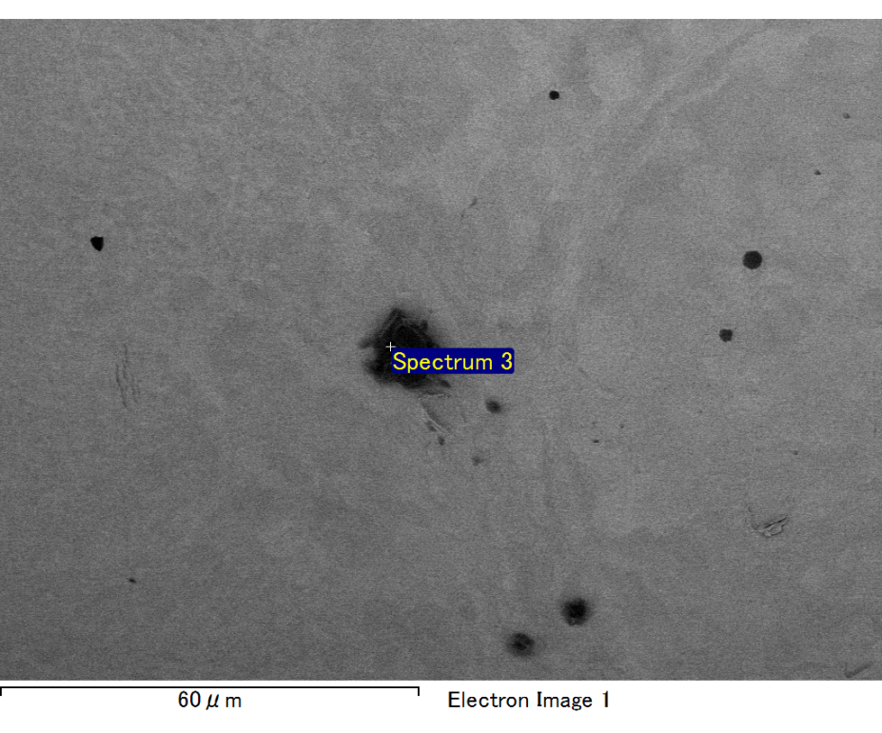

Spectrum processing :

No peaks omitted

Processing option : All elements analyzed (Normalised)

Number of iterations = 2

Standard :

C CaCO3 1-Jun-1999 12:00 AM

O SiO2 1-Jun-1999 12:00 AM

Mg MgO 1-Jun-1999 12:00 AM

Si SiO2 1-Jun-1999 12:00 AM

Fe Fe 1-Jun-1999 12:00 AM

Au Au 1-Jun-1999 12:00 AM

|  |  |  |  |
| --- | --- | --- | --- |
| Element | Weight% | Atomic% |  |
|  |  |  |  |
| C K | 2.98 | 10.57 |  |
| O K | 20.47 | 54.42 |  |
| Mg K | 6.15 | 10.76 |  |
| Si K | 4.34 | 6.58 |  |
| Fe L | 6.26 | 4.77 |  |
| Au M | 59.79 | 12.91 |  |
|  |  |  |  |
| Totals | 100.00 |  |  |

Spectrum Label: Spectrum 3

Livetime 60.0 s

Acquisition geometry ( degrees ):

Tilt = 15.0

Azimuth = 0.0

Elevation = 30.0

Accelerating voltage = 10.00 kV

Total spectrum counts = 51869

|  |  |  |  |
| --- | --- | --- | --- |
| Sample data : | Energy (eV) | Resn. (eV) | Area |
| Strobe : | 3.8 | 47.23 | 999866 |
|  |  |  |  |

No quant optimization performed

Sample: Sample 1

Type: Default

ID:

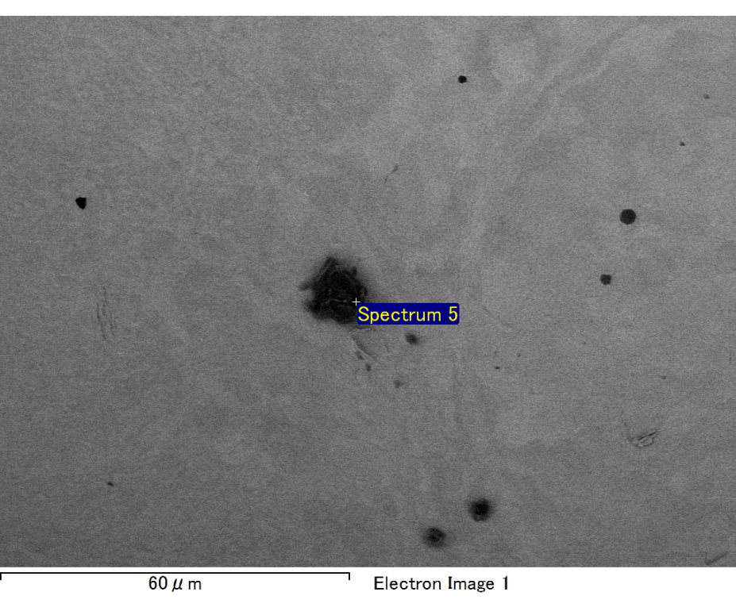

Spectrum processing :

No peaks omitted

Processing option : All elements analyzed (Normalised)

Number of iterations = 2

Standard :

C CaCO3 1-Jun-1999 12:00 AM

O SiO2 1-Jun-1999 12:00 AM

Mg MgO 1-Jun-1999 12:00 AM

Si SiO2 1-Jun-1999 12:00 AM

Fe Fe 1-Jun-1999 12:00 AM

Au Au 1-Jun-1999 12:00 AM

|  |  |  |  |
| --- | --- | --- | --- |
| Element | Weight% | Atomic% |  |
|  |  |  |  |
| C K | 3.64 | 13.99 |  |
| O K | 17.47 | 50.45 |  |
| Mg K | 4.73 | 8.98 |  |
| Si K | 3.05 | 5.02 |  |
| Fe L | 8.24 | 6.81 |  |
| Au M | 62.87 | 14.74 |  |
|  |  |  |  |
| Totals | 100.00 |  |  |

Spectrum Label: Spectrum 5

Livetime 60.0 s

Acquisition geometry ( degrees ):

Tilt = 15.0

Azimuth = 0.0

Elevation = 30.0

Accelerating voltage = 10.00 kV

Total spectrum counts = 53653

|  |  |  |  |
| --- | --- | --- | --- |
| Sample data : | Energy (eV) | Resn. (eV) | Area |
| Strobe : | 3.8 | 47.24 | 1000324 |
|  |  |  |  |

No quant optimization performed

Sample: Sample 1

Type: Default

ID:

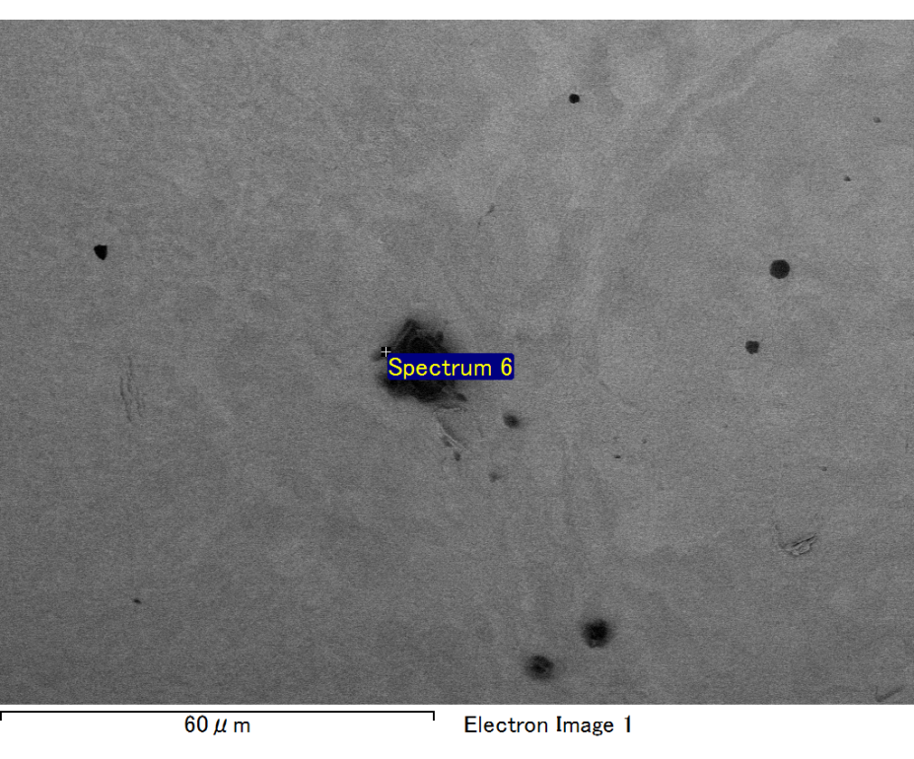

Spectrum processing :

No peaks omitted

Processing option : All elements analyzed (Normalised)

Number of iterations = 2

Standard :

C CaCO3 1-Jun-1999 12:00 AM

O SiO2 1-Jun-1999 12:00 AM

Mg MgO 1-Jun-1999 12:00 AM

Si SiO2 1-Jun-1999 12:00 AM

Fe Fe 1-Jun-1999 12:00 AM

Au Au 1-Jun-1999 12:00 AM

|  |  |  |  |
| --- | --- | --- | --- |
| Element | Weight% | Atomic% |  |
|  |  |  |  |
| C K | 3.28 | 14.79 |  |
| O K | 13.35 | 45.17 |  |
| Mg K | 3.68 | 8.18 |  |
| Si K | 2.51 | 4.83 |  |
| Fe L | 8.40 | 8.14 |  |
| Au M | 68.78 | 18.90 |  |
|  |  |  |  |
| Totals | 100.00 |  |  |

Spectrum Label: Spectrum 6

Livetime 60.0 s

Acquisition geometry ( degrees ):

Tilt = 15.0

Azimuth = 0.0

Elevation = 30.0

Accelerating voltage = 10.00 kV

Total spectrum counts = 53572

|  |  |  |  |
| --- | --- | --- | --- |
| Sample data : | Energy (eV) | Resn. (eV) | Area |
| Strobe : | 3.8 | 47.26 | 1000410 |
|  |  |  |  |

No quant optimization performed

Sample: Sample 1

Type: Default

ID: