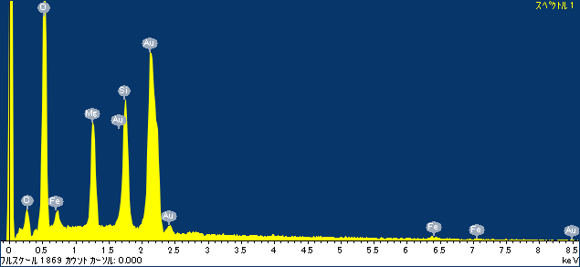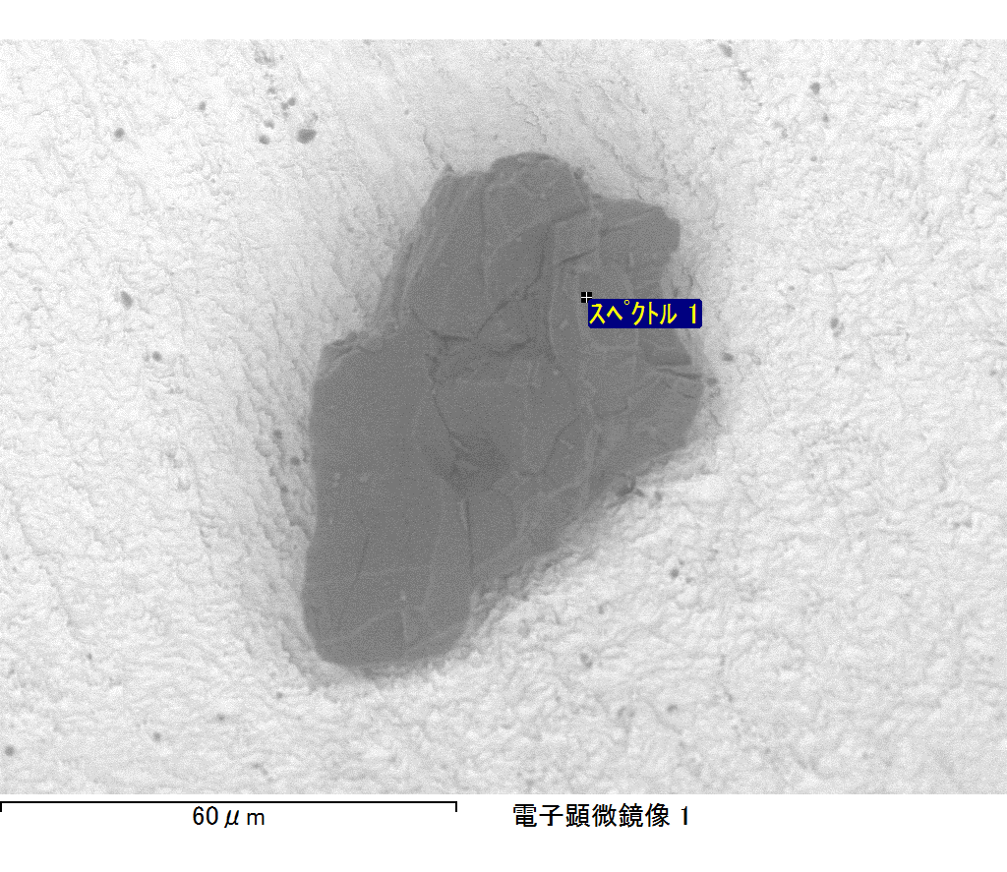

ｺﾒﾝﾄ :

2017/09/08 13:42:22

ﾌﾟﾛｼﾞｪｸﾄ 1

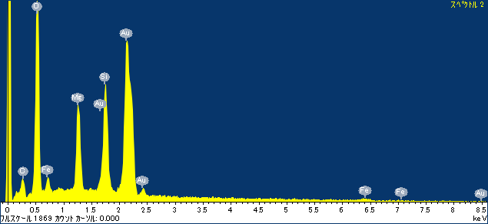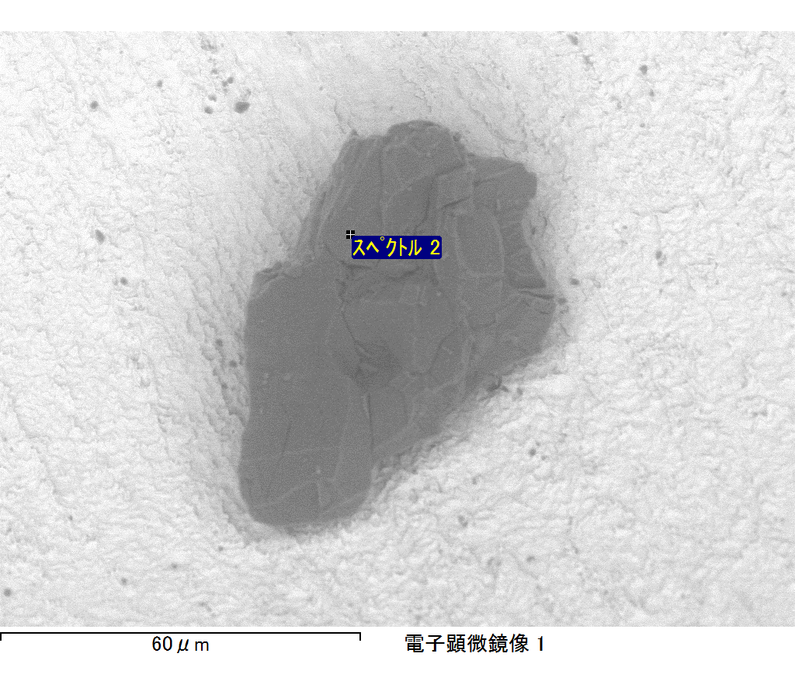

ｺﾒﾝﾄ :

2017/09/08 13:42:25

ﾌﾟﾛｼﾞｪｸﾄ 1

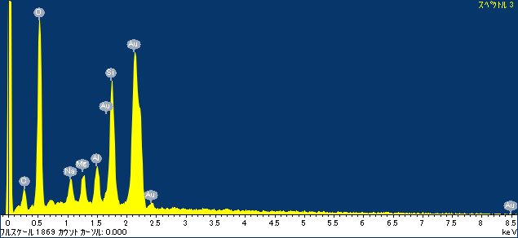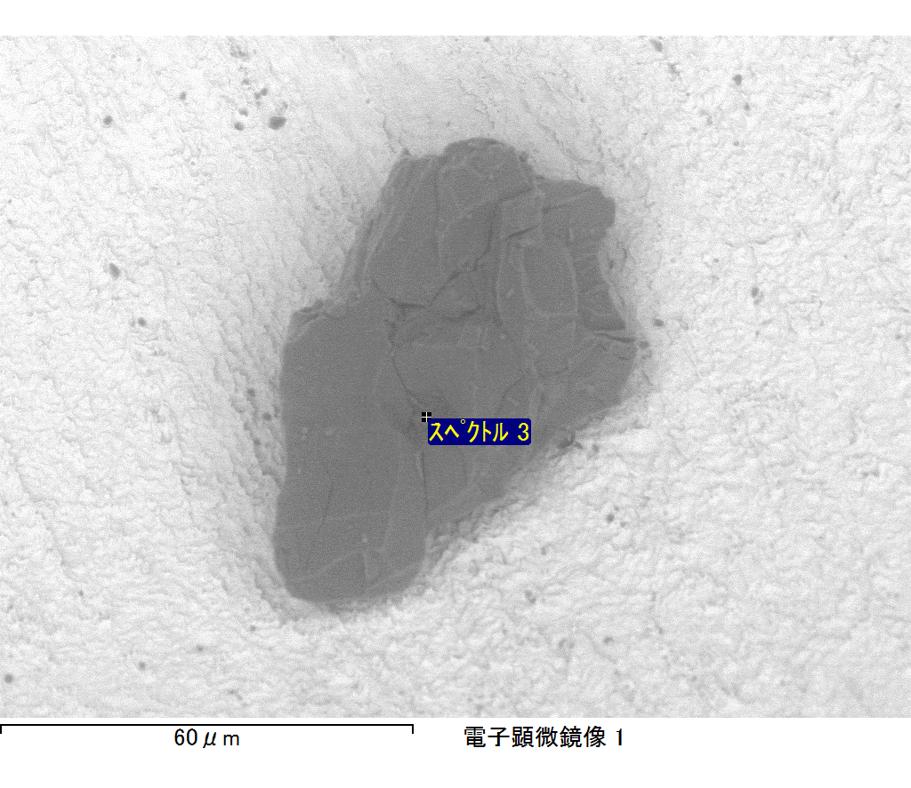

ｺﾒﾝﾄ :

2017/09/08 13:42:28

ﾌﾟﾛｼﾞｪｸﾄ 1

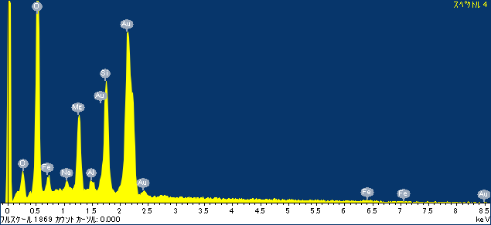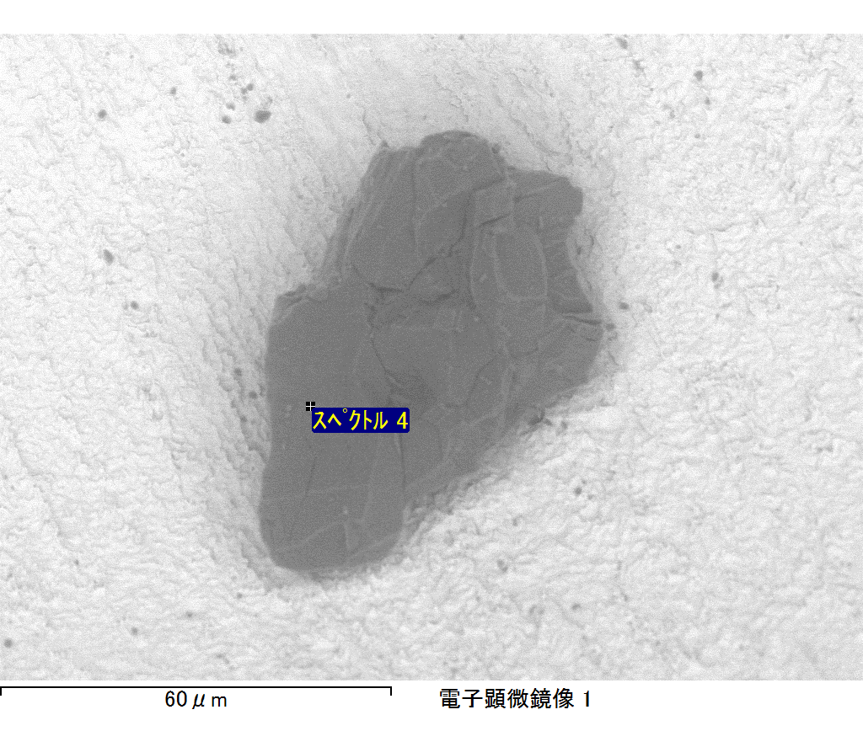

ｺﾒﾝﾄ :

2017/09/08 13:42:32

ﾌﾟﾛｼﾞｪｸﾄ 1

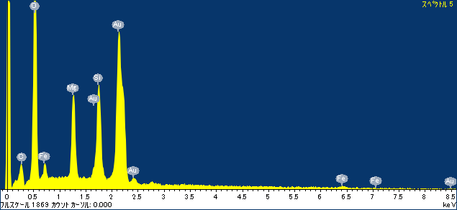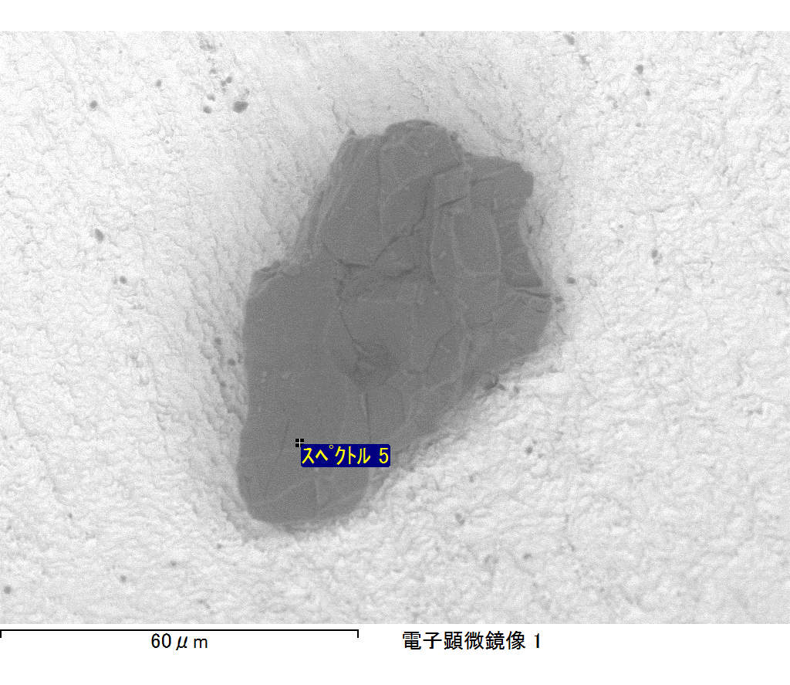

ｺﾒﾝﾄ :

2017/09/08 13:42:36

ﾌﾟﾛｼﾞｪｸﾄ 1